Group #: 6

**SQL-Mongo Project – Spatial Data of US Wildfires**

BUAN 6320

**Group Members:**

Sneha Santosh Bhagwat

Divya Deepak Pai

Astha Bansal

Rajas Prasannakumar Thakur

|  |  |  |  |  |
| --- | --- | --- | --- | --- |
| **Activity** | **Sneha** | **Divya** | **Astha** | **Rajas** |
| Prepared Data Model and Created Physical DB | X | X | X | X |
| Loaded Data into Database | X | X | X | X |
| Wrote SQL Queries | X | X | X | X |
| Prepared Mongo Database | X | X | X | X |
| Loaded data into Mongo DB | X | X | X | X |
| Wrote Mongo Queries | X | X | X | X |
| Prepared Report | X | X | X | X |
| Reviewed Report | X | X | X | X |

Contents

Data Model 6

Assumptions/Notes about Data set 6

Data Entities and Relationships 7

Entity-Relationship Diagram 9

Physical Database 10

Assumptions/Notes About Data Set 10

Screen shot of Physical Database objects 11

Data in the Database 21

SQL Queries 22

Query 1 22

Question 22

Notes/Comments About SQL Query and Results (Include # of Rows in Result) 22

Translation 22

Screen Shot of SQL Query and Results 23

Query 2 24

Question 24

Notes/Comments About SQL Query and Results (Include # of Rows in Result) 24

Translation 24

Screen Shot of SQL Query and Results 25

Query 3 26

Question 26

Notes/Comments About SQL Query and Results (Include # of Rows in Result) 26

Translation 26

Screen Shot of SQL Query and Results 27

Query 4 29

Question 29

Notes/Comments About SQL Query and Results (Include # of Rows in Result) 29

Translation 29

Screen Shot of SQL Query and Results 29

Query 5 30

Question 30

Notes/Comments About SQL Query and Results (Include # of Rows in Result) 30

Translation 30

Screen Shot of SQL Query and Results 31

Query 6 32

Question 32

Notes/Comments About SQL Query and Results (Include # of Rows in Result) 32

Translation 32

Screen Shot of SQL Query and Results 32

Data Review for MongoDB 33

Assumptions/Notes About Data Collections, Attributes and Relationships between Collections 33

Physical Mongo Database 34

Assumptions/Notes About Data Set 34

Screen shot of Physical Database objects (Database, Collections and Attributes) 34

Data in the Database 37

MongoDB Queries/Code 38

Query 1 38

Question 38

Notes/Comments About MongoDB Query/Code and Results (Include # of Documents in Result) 38

Translation 38

Screen Shot of MongoDB Query/Code and Results 38

Query 2 39

Question 39

Notes/Comments About MongoDB Query/Code and Results (Include # of Documents in Result) 39

Translation 39

Screen Shot of MongoDB Query/Code and Results 39

Query 3 40

Question 40

Notes/Comments About MongoDB Query/Code and Results (Include # of Documents in Result) 40

Translation 40

Screen Shot of MongoDB Query/Code and Results 40

Query 4 41

Question 41

Notes/Comments About MongoDB Query/Code and Results (Include # of Documents in Result) 41

Translation 41

Screen Shot of MongoDB Query/Code and Results 41

Query 5 43

Question 43

Notes/Comments About MongoDB Query/Code and Results (Include # of Documents in Result) 43

Translation 43

Screen Shot of MongoDB Query/Code and Results 43

Query 6 44

Question 44

Notes/Comments About MongoDB Query/Code and Results (Include # of Documents in Result) 44

Translation 44

Screen Shot of MongoDB Query/Code and Results 44

# Data Model

## Assumptions/Notes about Data set

* We are assuming that there is only one NWCG unit for a combination of code and state in NWCG_Unit_Location table
* After looking at the data, we have included following tables in the data model:

1. Fires

2. Nwcg_unitidactive_20170109

3. Idx_fires_shape_node

4. Idx_fires_shape_parent

5. Idx_fires_shape_rowid

All the other tables are excluded from our data model.

* There is identifying one-to-one relationship between Discovery_Data and Fires (In order to eliminate transitivity). Hence, the foreign key (FOD_ID) is also the primary key in Discovery_Data table.
* There is identifying one-to-one relationship between Controlled_Data and Fires. Hence, the foreign key (FOD_ID) is also the primary key in Controlled_Data table.
* From the given data, an ICS number is assigned to more than one fire. Hence, we have assumed there is one-to-many relationship between ICS and Fires. Also, as per the given dataset, some fires have not been assigned an ICS_209_Incident_Number.
* From the given data, a FIPS_CODE is assigned to more than one fire. Hence, we have assumed there is one-to-many relationship between FIPS and Fires. Also, as per the given dataset, some fires have not been assigned an FIPS_CODE.
* From the given data, an MTBS ID is assigned to more than one fire. Hence, we have assumed there is one-to-many relationship between MTBS and Fires. Also, as per the given dataset, some fires have not been assigned an MTBS ID.
* We have included parent_node of idx_Fires_Shape_parent table in idx_Fires_Shape_node table since all the other columns in both the tables were same and it was having one to one relationship.

**Data Entities and Relationships:**

* A Fire has **one and** **only one** Discovery_Data. A Discovery_Data is associated with **one and only one** Fire.
* A Fire has **one and only one** Controlled_Data. A Controlled_Data is associated with **one and only one** Fire.
* A Fire has **one and only one** Fire_Location. A Fire_Location can be location of **one to many** Fires.
* A Fire location is managed by **one and only one** Owner. An Owner can manage **one to many** Fire locations.
* A Fire has **one and only one** Fire_Location. Fire_Location can have **one to many** Fires.
* A Fire can have **zero to one** Incident Identifier (ICS). An ICS can be assigned to **one to many** Fires.
* A Fire has **one and only one** Fire_Size. A Fire_Size can be associated with **one to many** Fires.
* A Fire can have **zero to one** MTBS Incident Identifier. A MTBS Incident Identifier can be associated with **one to many** Fires.
* A Fire can have **zero to one** FIPS Code. A FIPS Code can be associated with **one to many** Fires
* A Fire can have **one and only one** Cause. A Cause can be related to **one to many** Fires.
* A Fire can have **one and only one** Source_System. A Source_system is related to **one to many** Fires.
* A Fire can be reported by **one and only one** Source_Reporting unit. A Source_Reporting unit can report **one to many** Fires.
* A Fire can be reported by **one and only one** NWCG_Unit. A NWCG_Unit can report **zero to many** Fires.
* A NWCG_Unit has **one and only one** NWCG_Unit_Location. A NWCG_Unit_Location has **one and only one** NWCG_Unit.
* A NWCG_Unit_Location has **one and only one** NWCG_State_Country. A NWCG_State_Country has **one to many** NWCG_Unit_Location.
* A Fire can have **one and only one** idx_Fires_Shape_rowid. A idx_Fires_Shape_rowid is associated with **one and only one** Fire.
* A idx_Fires_Shape_node can be associated with **one to many** idx_Fires_Shape_rowid. An idx_Fires_Shape_rowid is associated with **one and only one** idx_Fires_Shape_node.

**Reasons why the data model is in 3NF:**

* After performing Normalization, we can see that each table in the dataset has a **single value** in each cell. Also, while loading data in to the tables, we have loaded all the DISTINCT records. Hence, there are **unique rows** in each table. Thus, the **data model is in 1NF**.
* We have ensured that each non-key column is completely dependent on all the primary keys of the table. Thus, the data model **does not have partial dependency**. Thus, **it is in 2NF**.
* In order to remove transitive dependencies, the following actions were undertaken:

1. In Discovery_Data table, we can get date information using ‘DISCOVERY_DOY’ and ’FIRE_YEAR’ together, the issue of transitive dependency was arising as the non-key column (‘DISCOVERY_DATE’) was dependent on other non-key column (‘DISCOVERY_DOY’ and ’FIRE_YEAR’). So, we included ‘FIRE_YEAR’ column in Fires table to avoid transitive dependency.
2. Since OWNER_DESCR was dependent on OWNER_CODE (Non-key), we separated them from Fires table into a new table called Owner and made OWNER_CODE the primary key of that table.
3. Since FIRE_SIZE_CLASS was dependent on FIRE_SIZE (Non-key), we separated them from Fires table into a new table called FireSize and made fire_size the primary key of that table.
4. Since MTBS_FIRE_NAME was dependent on MTBS_ ID (Non-key), we separated them from Fires table into a new table called MTBS and made mtbs_id the primary key of that table.
5. Since STAT_CAUSE_DESCR was dependent on STAT_CAUSE_CODE(Non-key), we separated them from Fires table into a new table called Cause and made STAT_CAUSE_CODE the primary key of that table.
6. Since country was dependent on state (Non-key), we separated them from NWCG table into a new table called NWCG_State_Country and made state the primary key of that table.

* Thus, the data model has **no transitive dependency**. Hence, **it is in 3NF**.
* In this way, the entire data model now follows good database and normalization principles and is normalized to the best of our understanding.

## Entity-Relationship Diagram

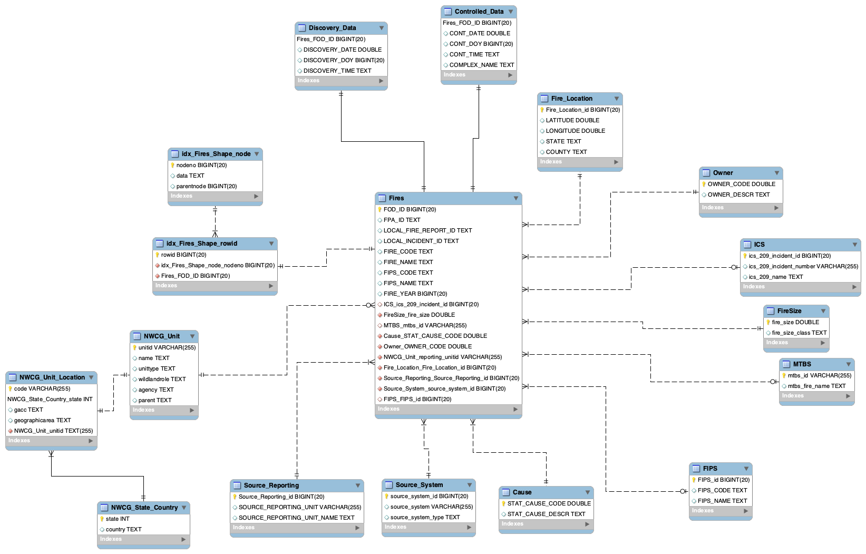

# Physical Database

## Assumptions/Notes About Data Set

Assumptions made about data such as empty fields, sparse data, bad data, etc.

* From the given data, we observed that ICS_209_Incident_Number is not unique for every ICS_209_NAME, and it also contains Null values. Hence, we introduced a new column i.e. ics_209_incident_id as Primary Key in ICS table, to enforce Unique and Not Null constraints of Primary Key Integrity.
* From the given data, we observed that FIPS_CODE is not unique for every FIPS_NAME, and it also contains Null values. Hence, we introduced a new column i.e. FIPS_id as Primary Key in FIPS table, to enforce Unique and Not Null constraints of Primary Key Integrity.
* From the given data, we observed that SOURCE_REPORTING_UNIT is not unique for every SOURCE_ REPORTING_UNIT_NAME. Hence, we introduced a new column i.e. Source_Reporting_id as Primary Key in Source_Reporting table, to enforce Unique constraint of Primary Key Integrity.
* From the given data, we observed that SOURCE_SYSTEM can have different SOURCE_SYSTEM_TYPE. Hence, we introduced a new column i.e. Source_System_id as Primary Key in Source_System table, to enforce Unique constraint of Primary Key Integrity.
* From the given data, there were Null values present in MTBS_ID and corresponding MTBS_NAME was null as well. Hence, in MTBS table, to incorporate Null values and to maintain Not Null integrity of primary key (mtbs_id), we changed Null value row of mtbs_id to ‘0’ and kept corresponding mtbs_name as Null.

## Screen shot of Physical Database objects

**Fires**

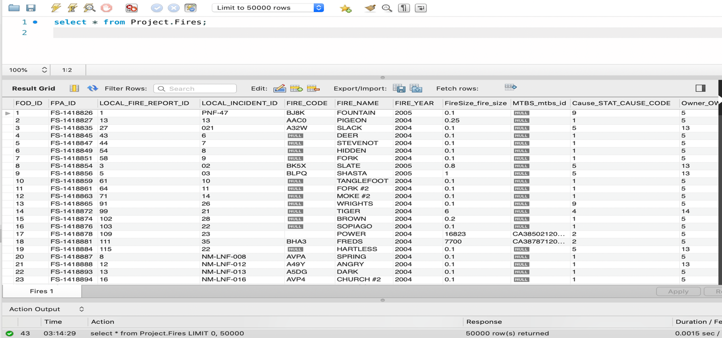

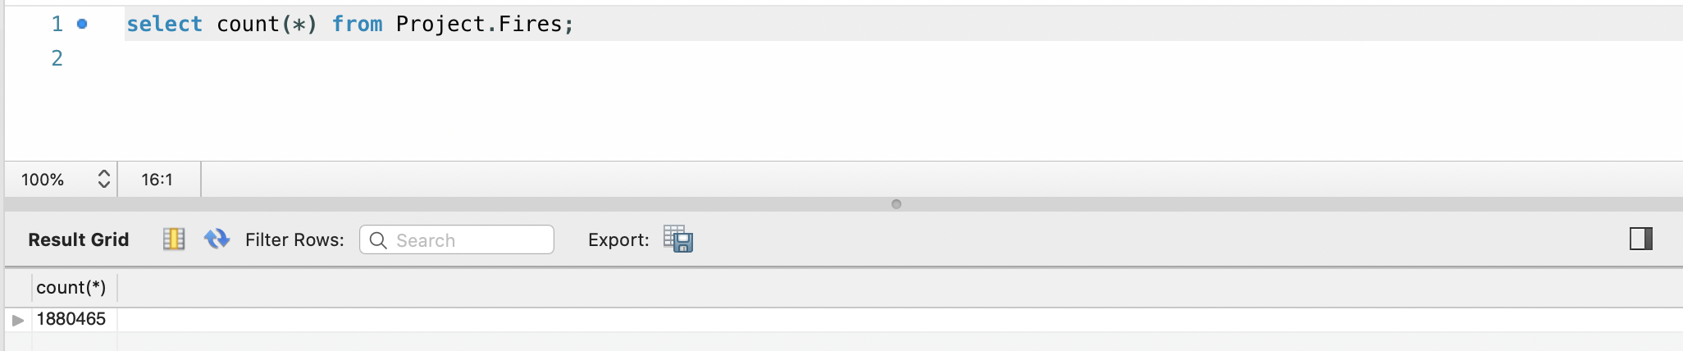

**Cause**

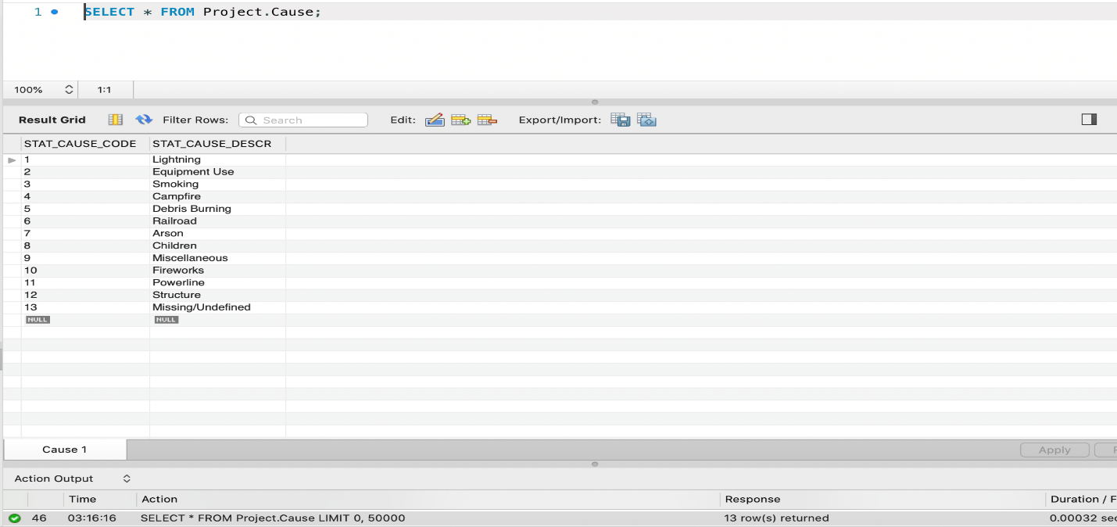

**Controlled_Data**

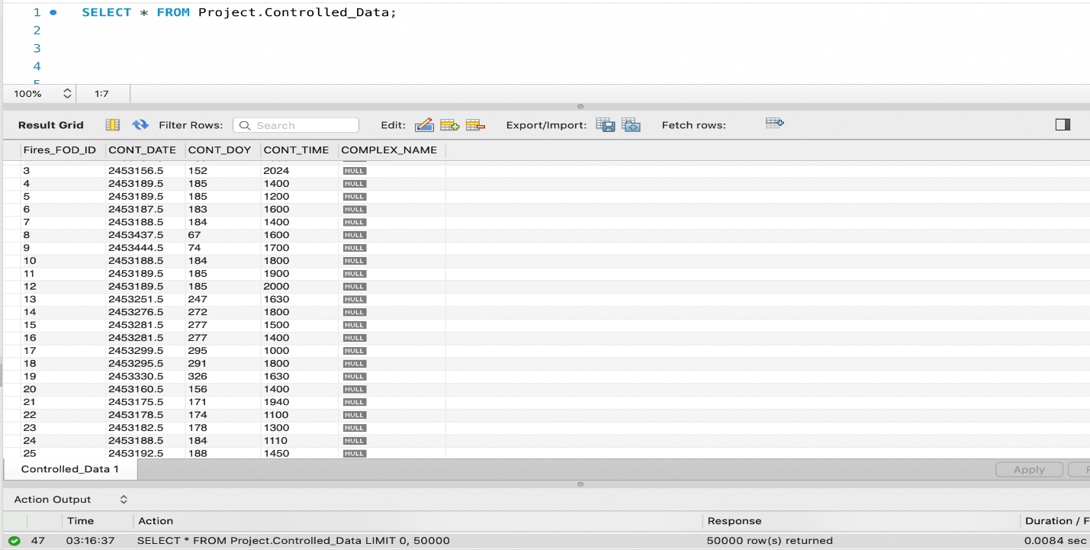

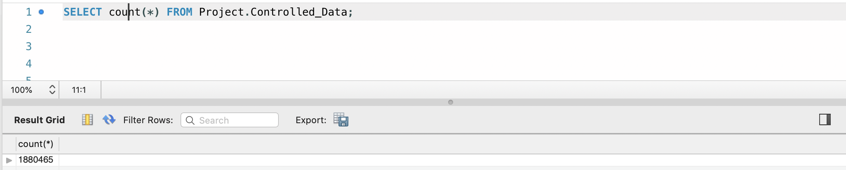

**Discovery_Data**

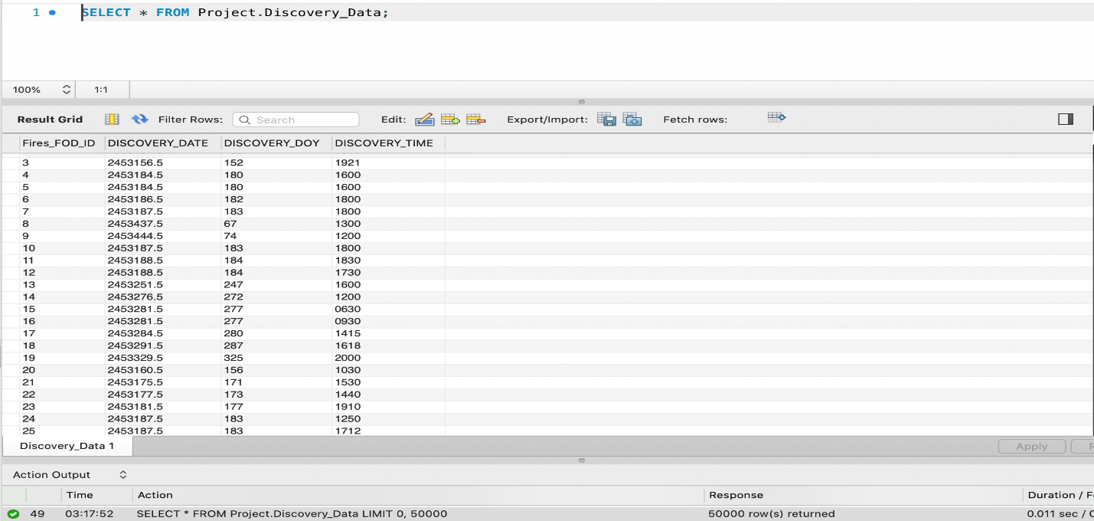

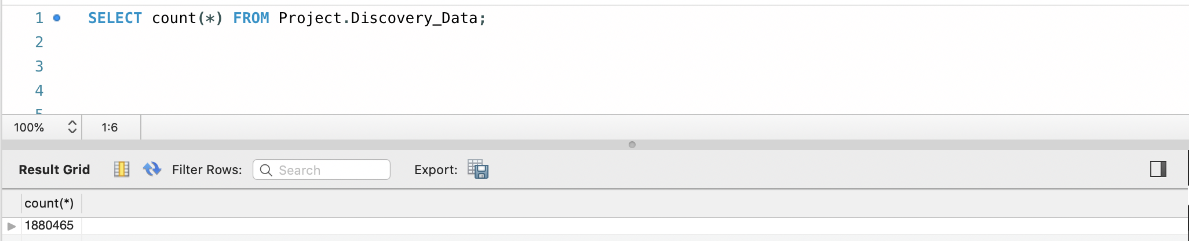

**FIPS**

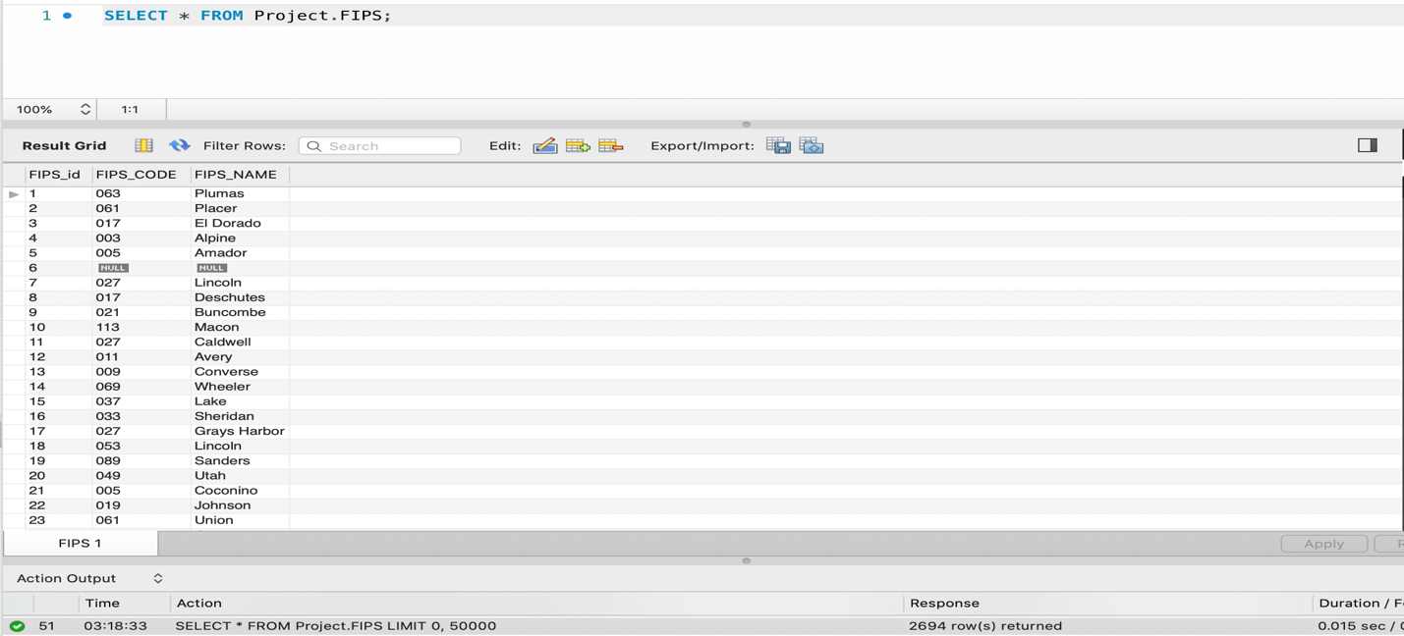

**Fire_Location**

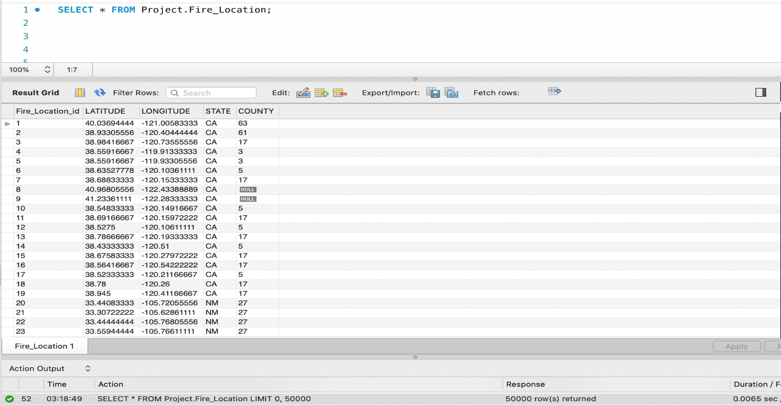

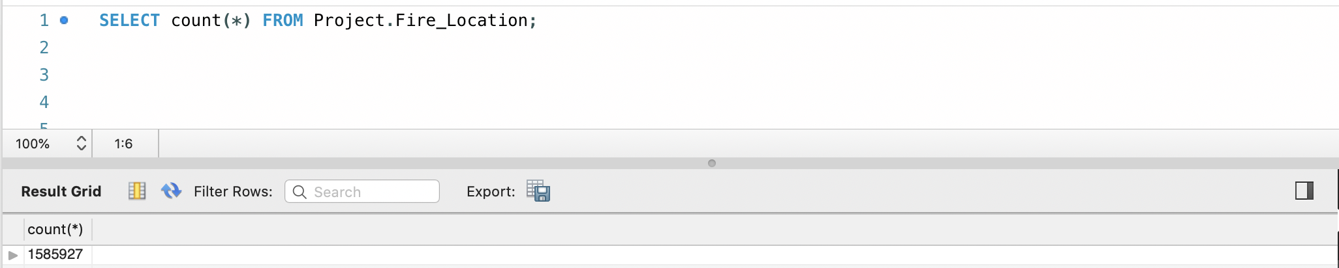

**FireSize**

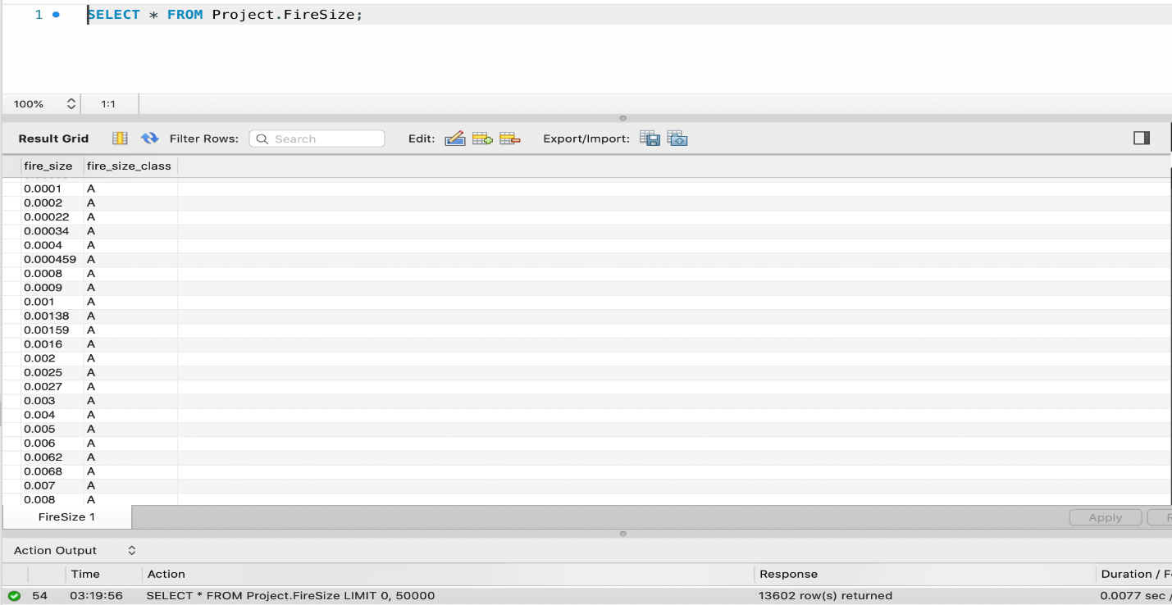

**ICS**

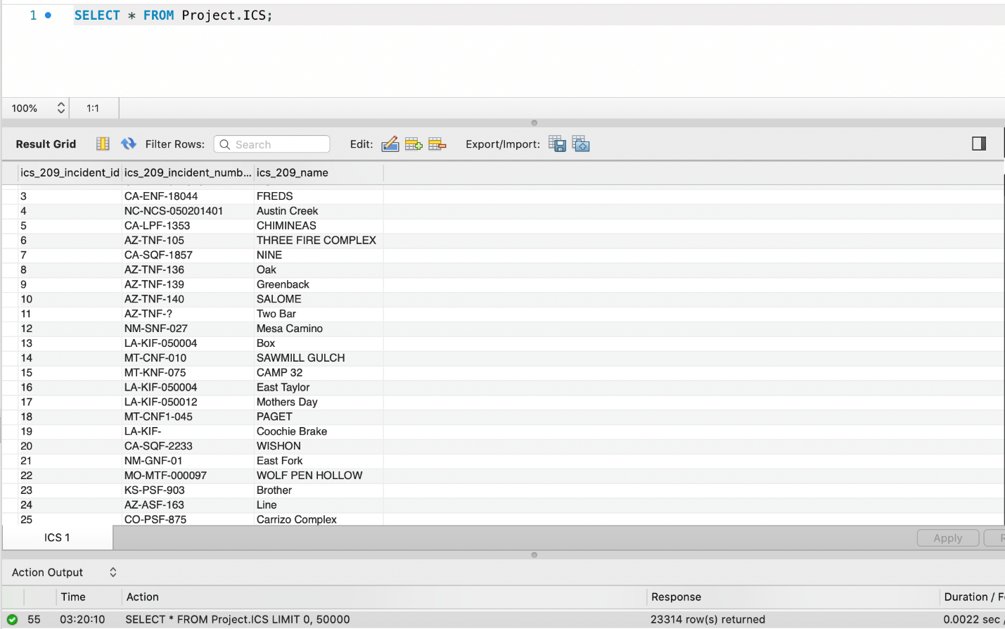

**MTBS**

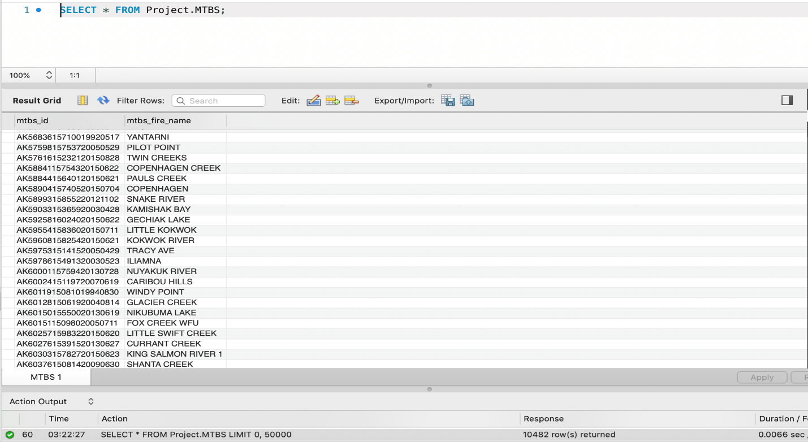

**Owner**

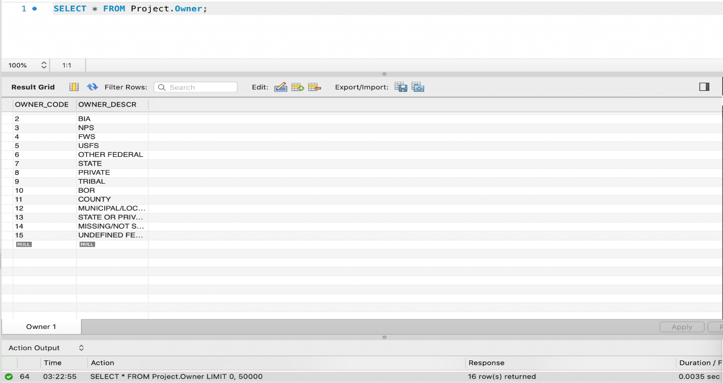

**Source_Reporting**

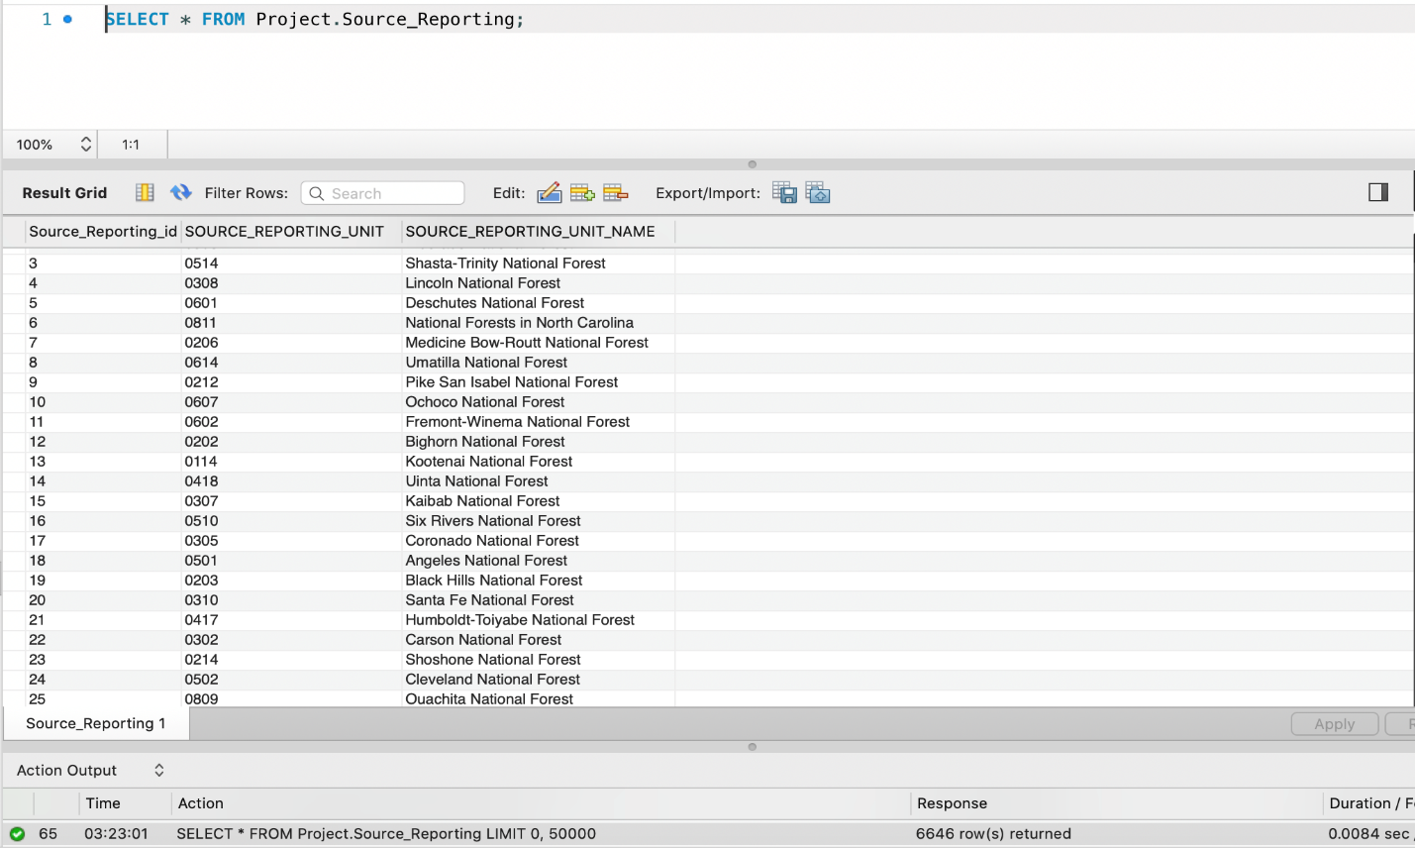

**Source_System**

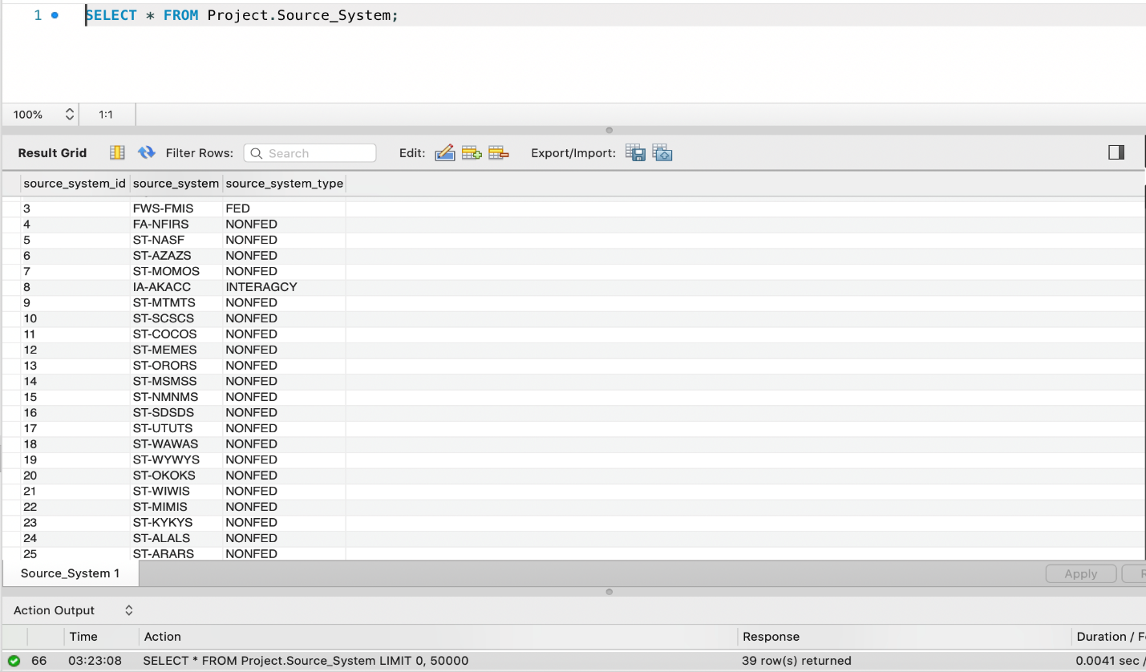

**NWCG_Unit**

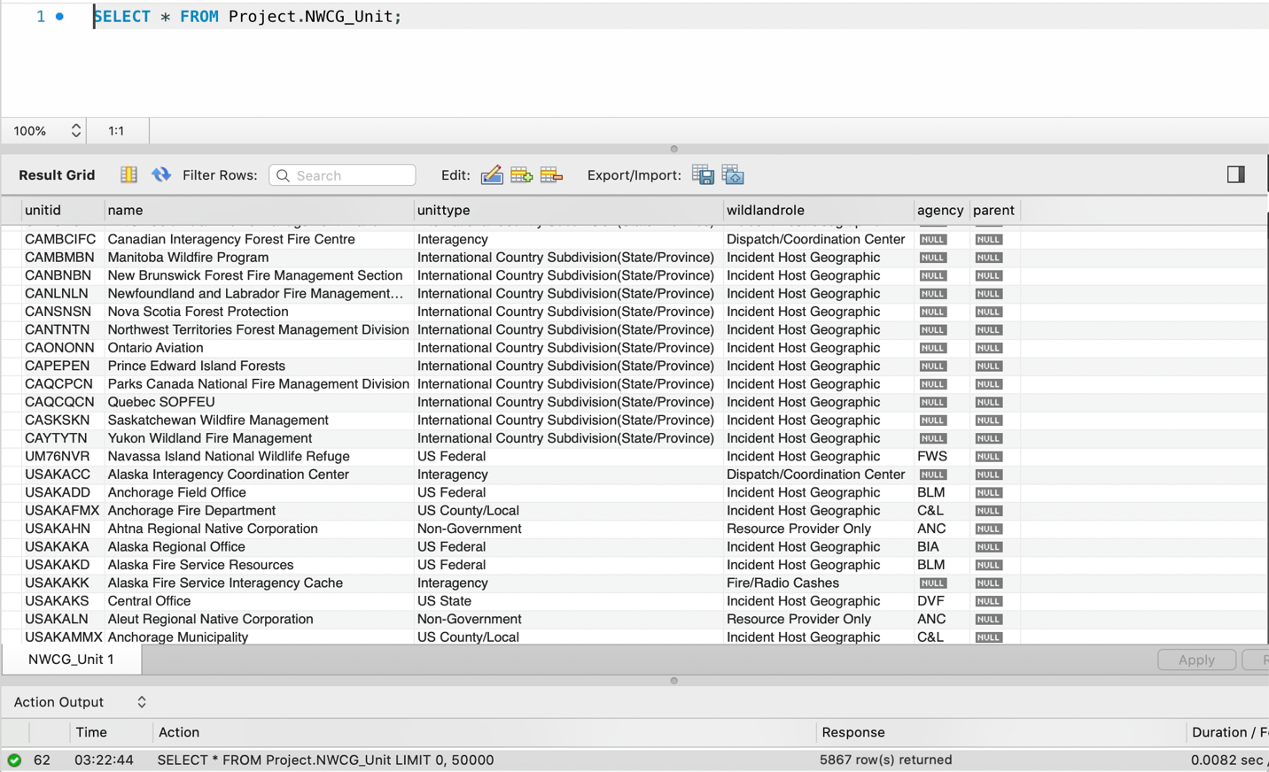

**NWCG_Unit_Location**

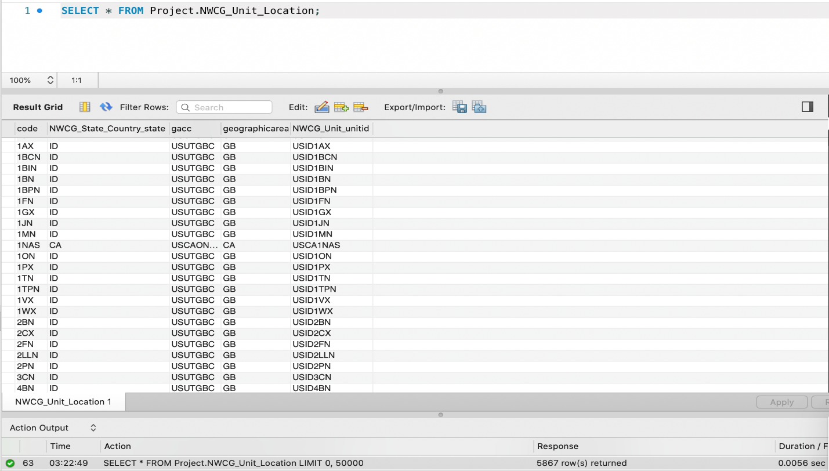

**NWCG_State_Country**

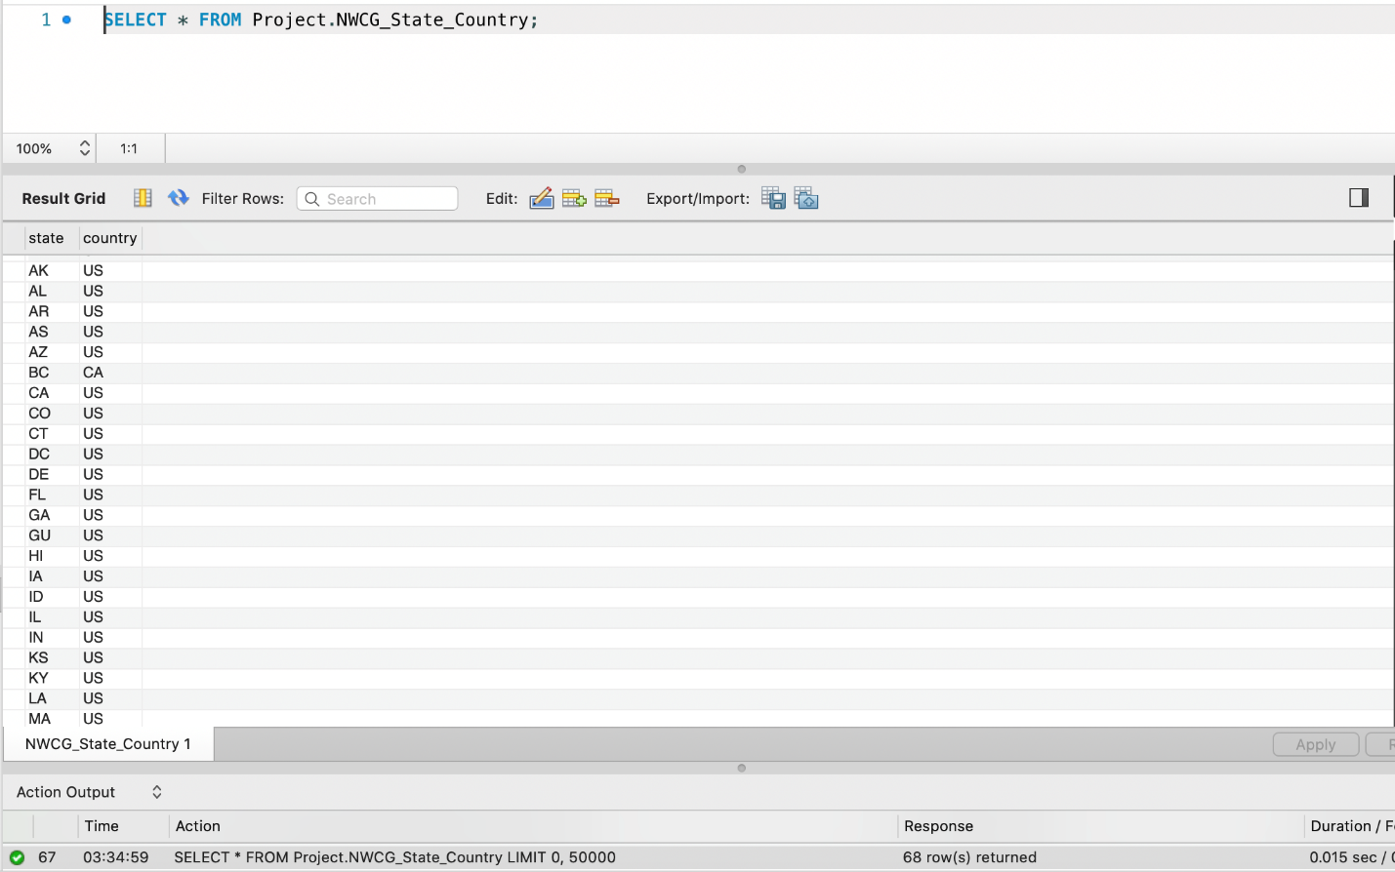

**Idx_Fires_Shape_node**

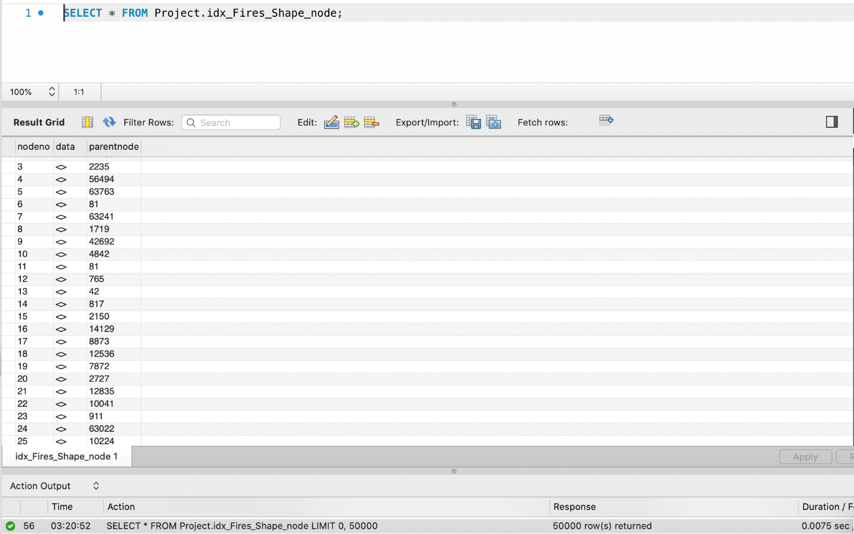

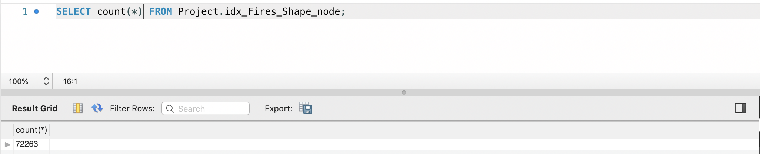

**Idx_Fires_Shape_rowid**

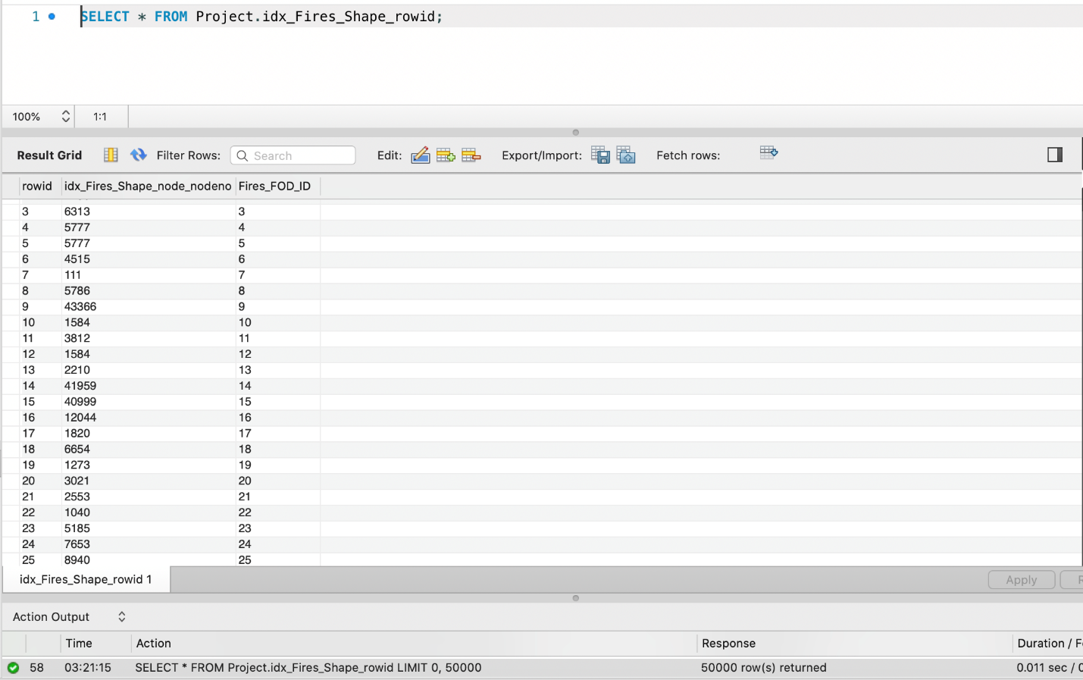

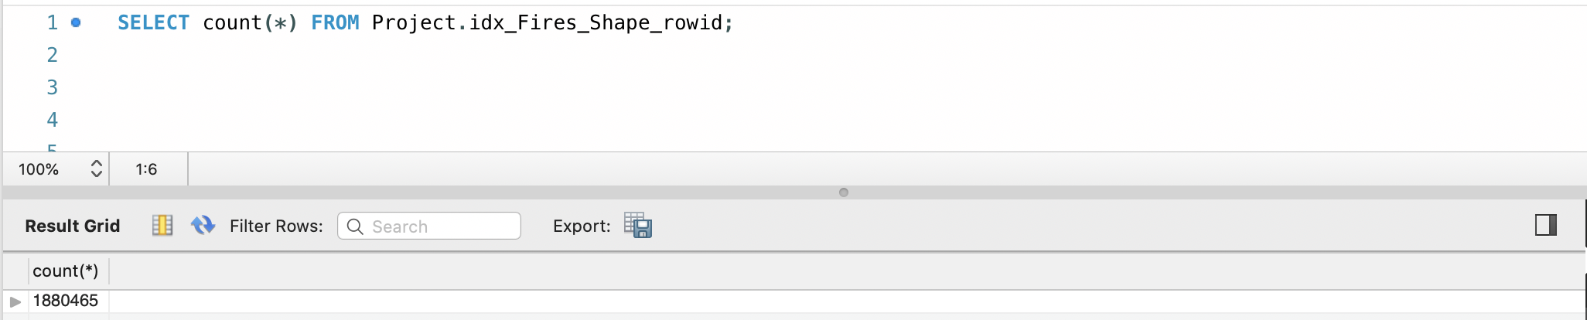

## Data in the Database

|  |  |  |  |
| --- | --- | --- | --- |
| **Table Name** | **Primary Key** | **Foreign Key** | **# of Rows in Table** |
| Fires | FOD_ID | 1. ICS_ics_209_incident_id  2. FireSize_fire_size  3. MTBS_mtbs_id  4. Cause_STAT_CAUSE_CODE  5. Source_Reporting_ Source_Reporting_id  6. Source_System_source_system_id  7. Owner_OWNER_CODE  8. Fire_Location_Fire_Location_id  9. NWCG_Unit_reporting_unitid  10. FIPS_FIPS_id | 1880465 |
| Discovery_Data | Fires_FOD_ID | Fires_FOD_ID | 1880465 |
| Controlled_Data | Fires_FOD_ID | Fires_FOD_ID | 1880465 |
| Fire_Location | Fire_Location_id |  | 1585927 |
| Owner | OWNER_CODE |  | 16 |
| ICS | ics_209_incident_id |  | 23314 |
| FireSize | fire_size |  | 13602 |
| MTBS | mtbs_id |  | 10482 |
| Cause | STAT_CAUSE_CODE |  | 13 |
| Source_Reporting | Source_Reporting_id |  | 6646 |
| Source_System | source_system_id |  | 39 |
| FIPS | FIPS_id |  | 2694 |
| NWCG_Unit | unitid |  | 5867 |
| NWCG_Unit_Location | code  NWCG_State_Country_state | NWCG_Unit_unitid  NWCG_State_Country_state | 5867 |
| NWCG_State_Country | state |  | 68 |
| Idx_Fires_Shape_rowid | rowid | Idx_Fires_Shape_node_nodeno  Fires_FOD_ID | 1880465 |
| Idx_Fires_Shape_node | nodeno |  | 72263 |

# SQL Queries

## Query 1

### Question

**Q 1) A leading beverage company has announced a billion-dollar fund for removing debris from forests, rivers and mountains in the US. All states are interested. Which state has the best chance to win a share of the fund?**

### Notes/Comments About SQL Query and Results (Include # of Rows in Result)

**Here the beverage company would most likely give a share of the fund to the state which has highest count of fires caused due to debris burning – so that the state can use the fund to clean its debris and reduce the number of fires caused due to it in future.**

### Translation

**Select State Name from Fire_Location table, Count(FOD_ID from Fires table) having cause debris burning from Fire_Location table**

**joined with Fires table on Fire_Location_id in Fires_Location table**

**joined with Cause table on stat_cause_code in Fires table**

**where STAT_CAUSE_DESCR is Debris**

**grouped by State Name**

**Sorted in descending order of number of fires**

**Limiting the number of rows to 1**

### Clean Up

**Select State Name from Fire_Location, Count(FOD_ID from Fires) from Fire_Location**

**join Fires on Fire_Location_id in Fires_Location**

**join Cause on stat_cause_code in Fires**

**where STAT_CAUSE_DESCR like `%Debris%‘**

**group by State Name**

**order by 2 desc**

**limit 1**

### 

### Screen Shot of SQL Query and Results

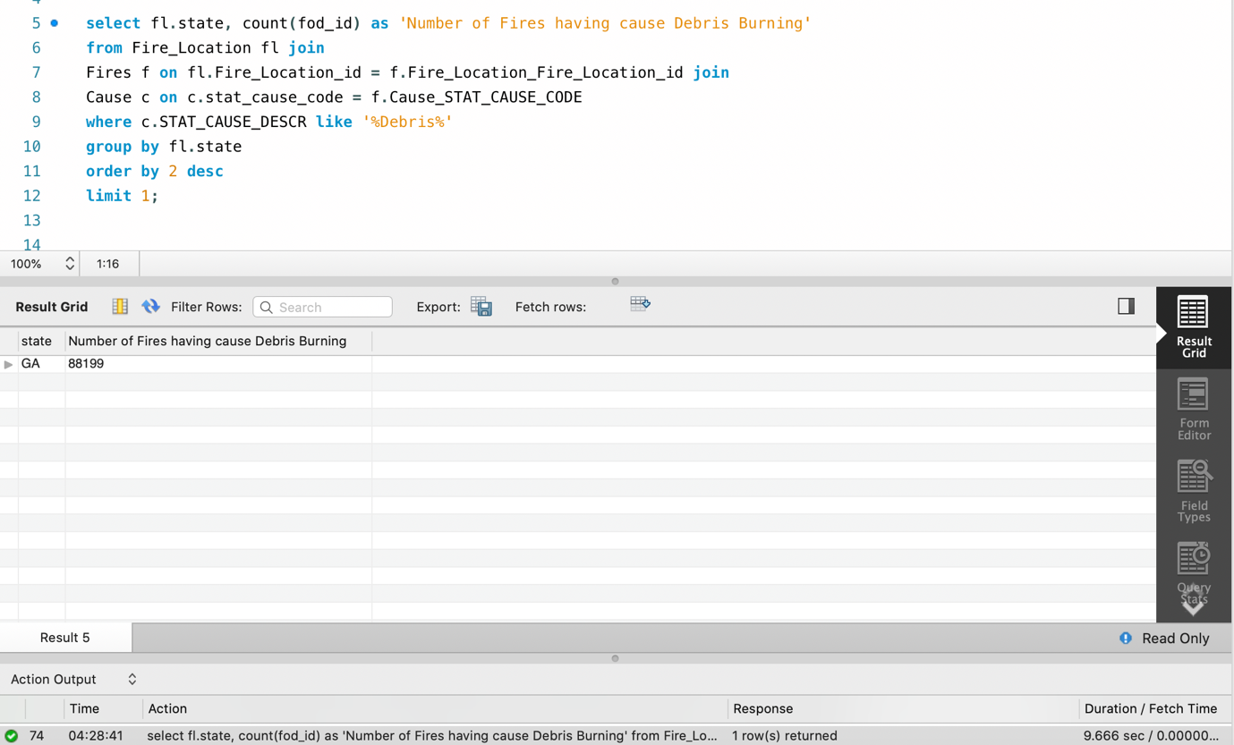

**The state of Georgia (GA) had the most no. of fires (88199) caused due to Debris Burning. Hence, Georgia has the best chance to win.**

## Query 2

### Question

**Q 2) One of the reporting agencies has suggested that children be banned from its forests unless there is one adult for every 3 children in a group visiting a forest. Name 3 forests where this would be the most appropriate.**

### Notes/Comments About SQL Query and Results (Include # of Rows in Result)

**Here we need to find top 3 forests where most fires are caused by children. That is, children are the cause of Fires. Such forests would need a rule of children being accompanied by an adult to prevent fires caused by them in future.**

**Assumption: We have considered NWCG_Reporting_Unit field for our results.**

### Translation

**Select number of fires, Forest name, cause of fire from NWCG_Unit table**

**joined with Fires table on unitid in NWCG_Unit table**

**joined with Cause table on stat_cause_code in Fires table**

**where cause of fire was Children**

**grouped by Forest Name, Cause**

**sorted in descending order of number of fires**

**limiting the number of rows to 3**

### Clean Up

**Select count(Name from NWCG_Unit), Forest name, Cause from NWCG_Unit**

**join Fires on unitid in NWCG_Unit**

**join Cause on stat_cause_code in Fires**

**where cause like `% Children%‘**

**group by Forest Name, Cause**

**order by Number of Fires desc**

**Limit 3**

### Screen Shot of SQL Query and Results

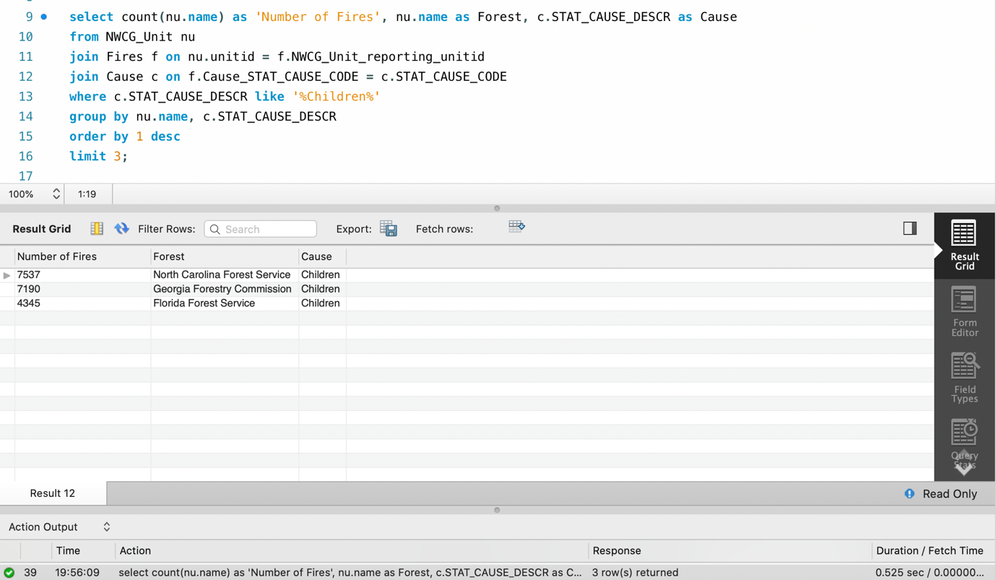

**The 3 forests: North Carolina Forest, Georgia Forest, Florida Forest had the most fires caused due to Children. Hence, these are the 3 forests where the ban would be the most appropriate.**

## Query 3

### Question

**Q 3) One advocacy group says Nature and not human actions is to blame for most wildfires. Write a query that supports this statement.**

### Notes/Comments About SQL Query and Results (Include # of Rows in Result)

### **As per the NWCG Report, Debris burn escapes are one of the leading specific causes of wildland fires. Windblown embers or fire creeping from the controlled burn area into un-cleared vegetation are the primary ignition mechanisms of the wildfire. Hence, we make 2 assumptions about wildfires when cause is debris.**

Assumption 1: **We consider debris burning as Natural cause. Now we can support the claim of advocacy group that nature and not human actions is to blame for most wildfires.**

### Translation

**Select number of fires due to Man-made Cause,**

**select number of fires due to Natural cause from fires table where Cause_stat_code is in**

**select stat_cause_code from Cause table where Cause is Lightning or Debris**

**from Fires table**

**where cause_stat_cause_code is not in**

**select stat_cause_code from Cause table**

**where cause is Lightning, Miscellaneous, Missing/Undefined or Debris**

### Clean Up

**Select count(*) as `Man-made Cause‘,**

**select count(*) from Fires where Cause_stat_cause_code in (**

**select stat_cause_code from Cause from Fires where stat_cause_descr = `%Lightning%‘ or**

**stat_cause_descr = `%Debris%‘ )**

**where cause_stat_cause_code not in (**

**select stat_cause_code from Cause**

**where stat_cause_descr = `%Lightning%‘ or stat_cause_descr = %Miscellaneous%‘ or**

**stat_cause_descr = `%Missing/Undefined%` or ` stat_cause_descr = %Debris%` )**

### 

### Screen Shot of SQL Query and Results

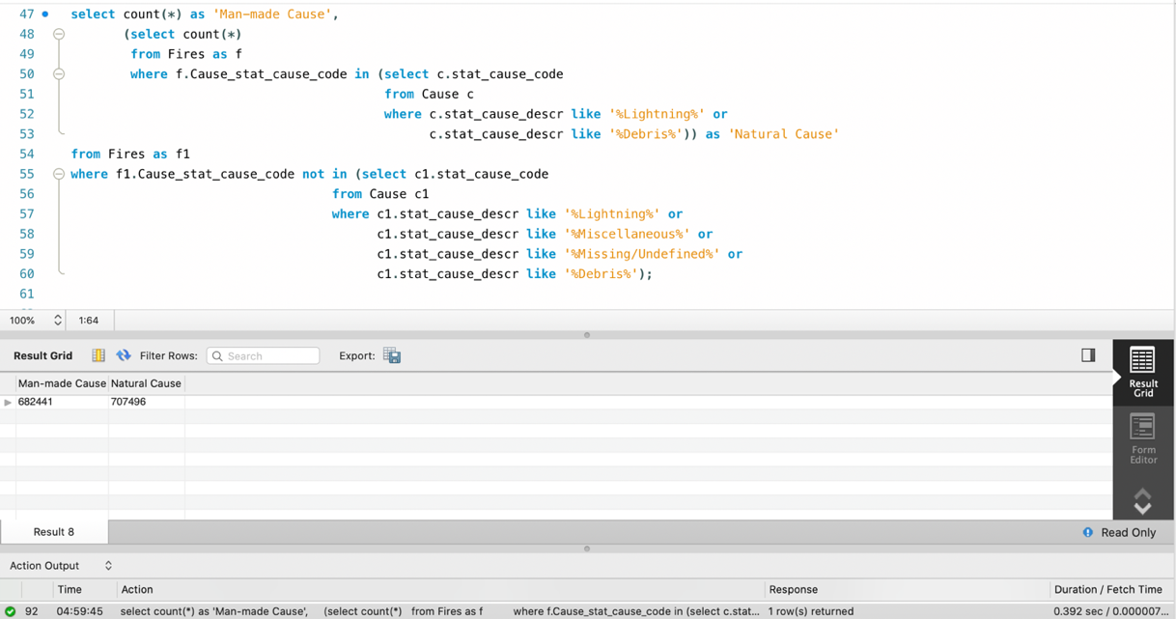

**The above query does support the statement claimed that Nature and not human actions is to blame for most wildfires.**

Assumption 2: **If we consider debris burning as both man-made and natural cause of fires and hence not include in any group. Hence, here we cannot support the claim of advocacy group.**

### Translation

**Select count of fires due to Man-made Cause,**

**Select count of Natural Cause Fires from fires table where Cause_stat_code is in**

**select stat_cause_code from Cause table where Cause is Lightning**

**from Fires table**

**where cause_stat_cause_code is not in**

**select stat_cause_code from Cause table**

**where cause is Lightning, Miscellaneous, or Missing/Undefined**

### Clean Up

**Select count(*) as `Man-made Cause‘,**

**Select count(*) from Fires where Cause_stat_code in (**

**select stat_cause_code from Cause from Fires where stat_cause_descr = `%Lightning%` )**

**where cause_stat_cause_code not in (**

**Select stat_cause_code from Cause**

**where stat_cause_descr = `%Lightning%` or stat_cause_descr = `%Miscellaneous%` or stat_cause_descr = `%Missing/Undefined%` )**

### Screen Shot of SQL Query and Results

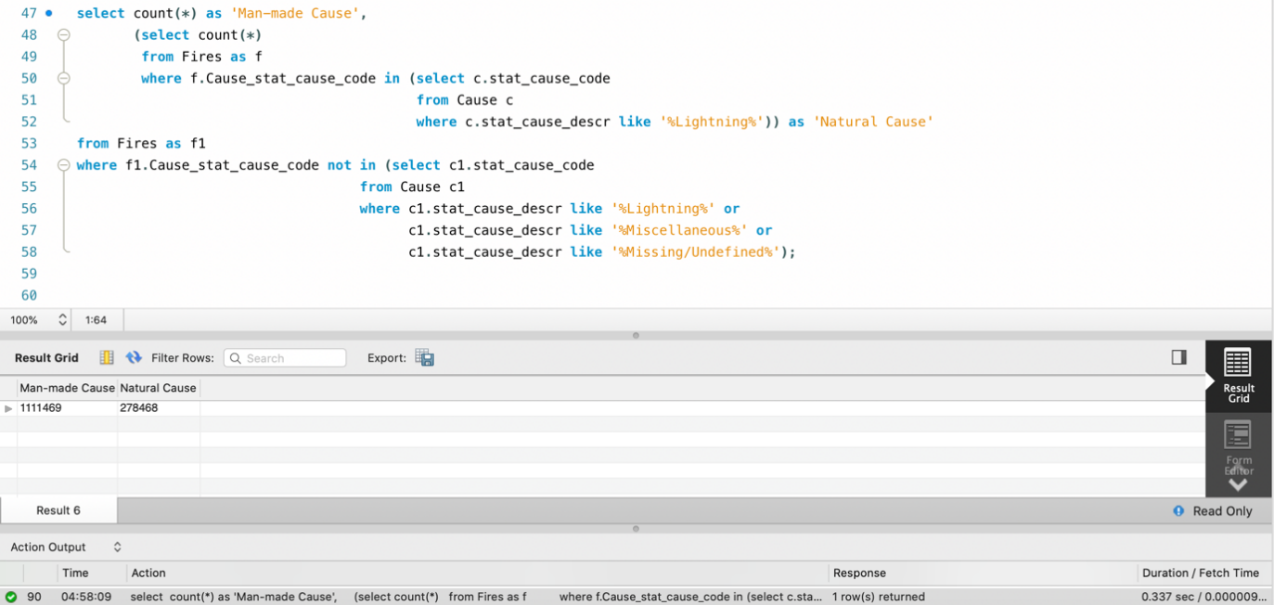

**The above query does not support the statement claimed that Nature and not human actions is to blame for most wildfires.**

## Query 4

### Question

**Q 6) What were the forests that had more than one fire that lasted more than two days?**

### Notes/Comments About SQL Query and Results (Include # of Rows in Result)

**We have considered NWCG_Unit table which contains a list of Forest names.**

### Translation

**Select distinct Forest Name from NWCG_Unit table**

**joined with Fires table on NWCG_Unit_reporting_unitid in NWCG_Unit table**

**joined with Controlled_Data table on FOD_ID in Fires table**

**joined with Discovery_Data table on FOD_ID in Fires table**

**where fire lasted for more than two days**

**grouped by Forest Name**

**having occurence of more than one fire given by FOD_ID in Fires table**

### Clean Up

**Select distinct Name from NWCG_Unit**

**Join Fires on NWCG_Unit_reporting_unitid in NWCG_Unit**

**Join Controlled_Data on FOD_ID in Fires**

**Join Discovery_Data on FOD_ID in Fires**

**where datediff(CONT_Date in Controlled_Data, DISCOVERY_Date in Discovery_Data) > 2 AND**

**FOD_ID in Fires > 1**

**Group by Name in NWCG_Unit**

### Screen Shot of SQL Query and Results

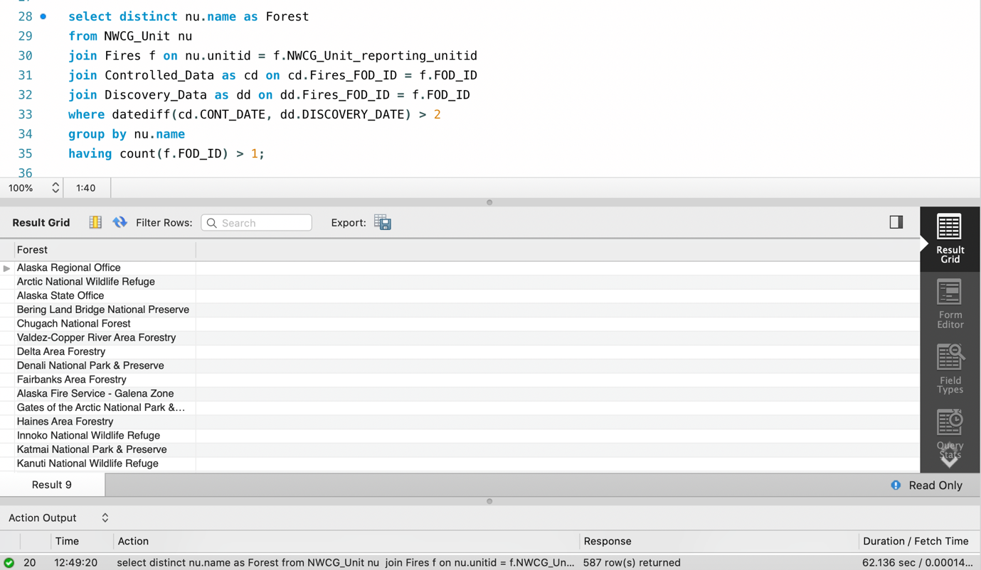

## Query 5

### Question

**Q 7) Which state had more fires in the second half of a calendar year than the first half of the calendar year?**

### Notes/Comments About SQL Query and Results (Include # of Rows in Result)

**We have shown total number of fires in first half of calendar year as well as those in second half for side by side comparison.**

### Translation

**Select state2, count1, count2 from (**

**Select state from Fire_Location table, count(FOD_ID from Fires table)**

**Where Discovery_Date from Discovery_Data table is greater than 6 AND**

**Fire_Location_ID from Fire_Location table is equal to Fire_Location_ID from Fires table AND**

**FOD_ID from Fires table is equal to FOD_ID from Discovery_Data table**

**Grouped by state from Fire_Location table )**

**Joined with**

**Select state from Fire­_Location table, count(FOD_ID from Fires table) from**

**Fire_Location table, Fires table, Discovery_Data table**

**Where Discovery_Date from Discovery_Data table is less than or equal to 6 AND**

**Fire_Location_ID from Fire_Location table is equal to Fire_Location_ID from Fires table AND**

**FOD_ID from Fires table is equal to FOD_ID from Discovery_Data table**

**Grouped by state from Fire_Location table ON state1 equals state2**

### Clean Up

**Select state2, count1, count2 from (**

**Select state from Fire_Location, count(FOD_ID from Fires)**

**Where Discovery_Date from Discovery_Data > 6 AND**

**Fire_Location_ID from Fire_Location = Fire_Location_ID from Fires AND**

**FOD_ID from Fires = FOD_ID from Discovery_Data**

**Group by state from Fire_Location )**

**Joined with**

**Select state from Fire­_Location, count(FOD_ID from Fires) from**

**Fire_Location , Fires , Discovery_Data**

**Where Discovery_Date from Discovery_Data <= 6 AND**

**Fire_Location_ID from Fire_Location = Fire_Location_ID from Fires AND**

**FOD_ID from Fires = FOD_ID from Discovery_Data**

**Group by state from Fire_Location ON s1.state1 = s2.state2**

### 

### Screen Shot of SQL Query and Results

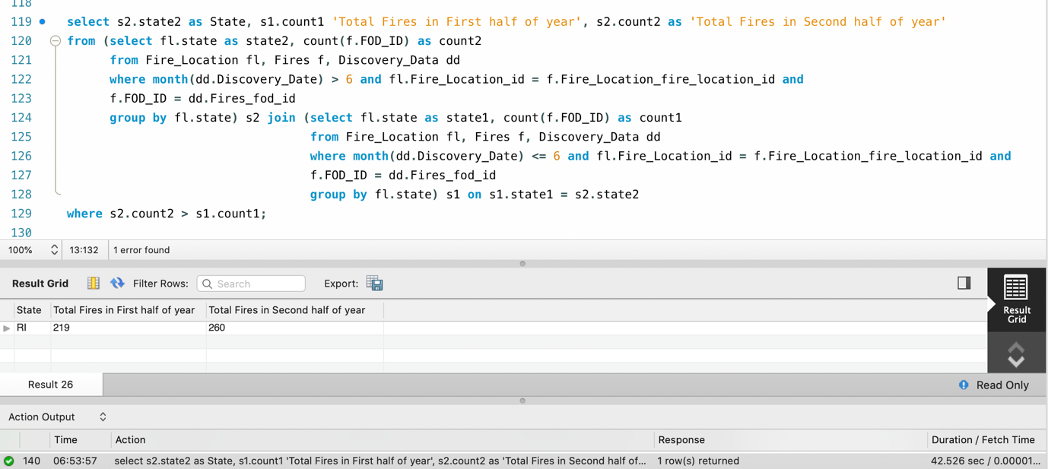

**The state of Rhode Island (RI) had more fires in the second half of the year than in the first half.**

## Query 6

### Question

**Q 8) Which forest had the most number of fires?**

### Notes/Comments About SQL Query and Results (Include # of Rows in Result)

**We have considered NWCG_Unit and NWCG_Unit_reporting tables for our results.**

### Translation

**Select count(Name from NWCG_Unit table), Forest Name from NWCG_Unit table**

**Joined with Fires table on unitid in NWCG_Unit table**

**Grouped by Forest name**

**Sorted in descending order of Number of Fires**

**Limiting the number of records to 1**

### Clean Up

**Select count(Name from NWCG_Unit), Forest Name from NWCG_Unit**

**Join Fires on unitid in NWCG_Unit**

**Group by name in NWCG_Unit**

**Order by 1 desc**

**Limit 1**

### 

### Screen Shot of SQL Query and Results

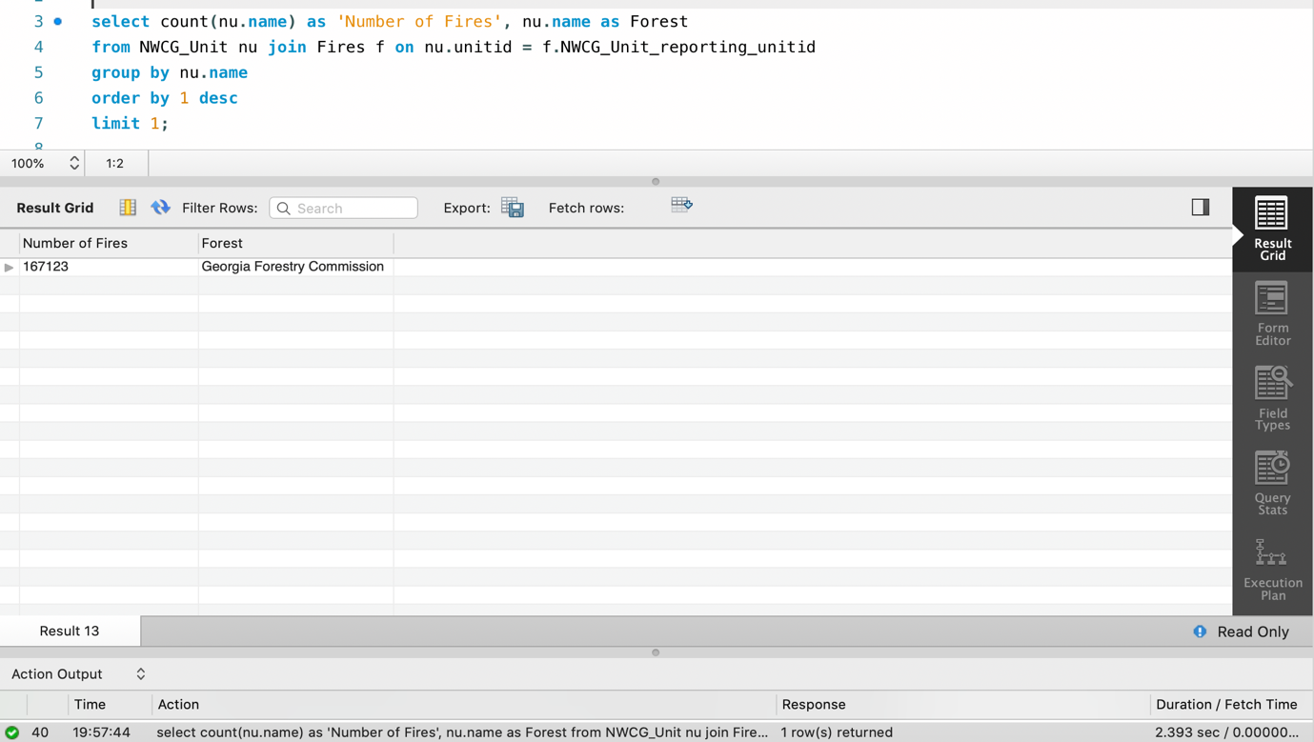

**The Georgia Forest had the most number of fires (167123).**

# Data Review for MongoDB

## Assumptions/Notes About Data Collections, Attributes and Relationships between Collections

**We have considered two primary collections – Fires and NWCG_Unit.**

# Physical Mongo Database

## Assumptions/Notes About Data Set

**We have considered two collections – Fires and NWCG_Unit as the primary collections.**

## Screen shot of Physical Database objects (Database, Collections and Attributes)

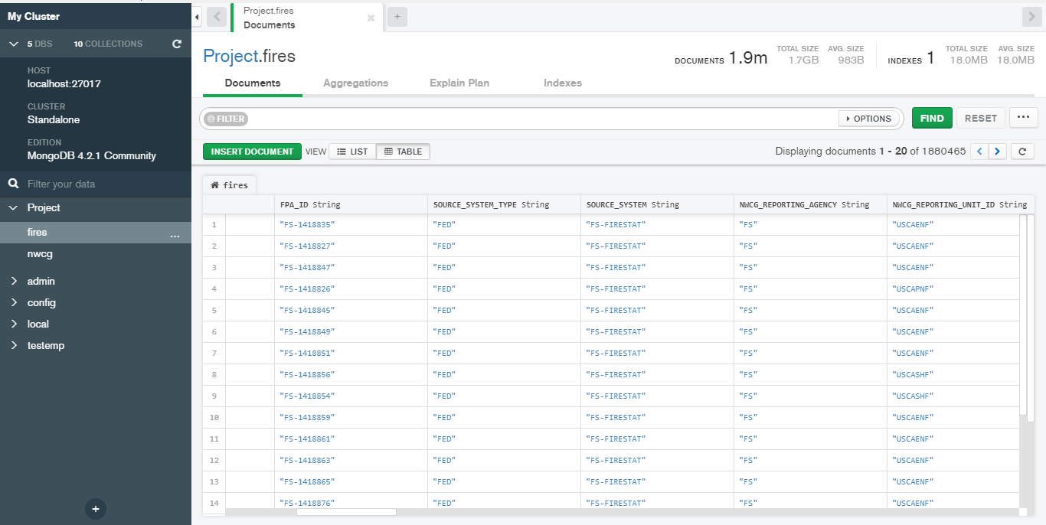

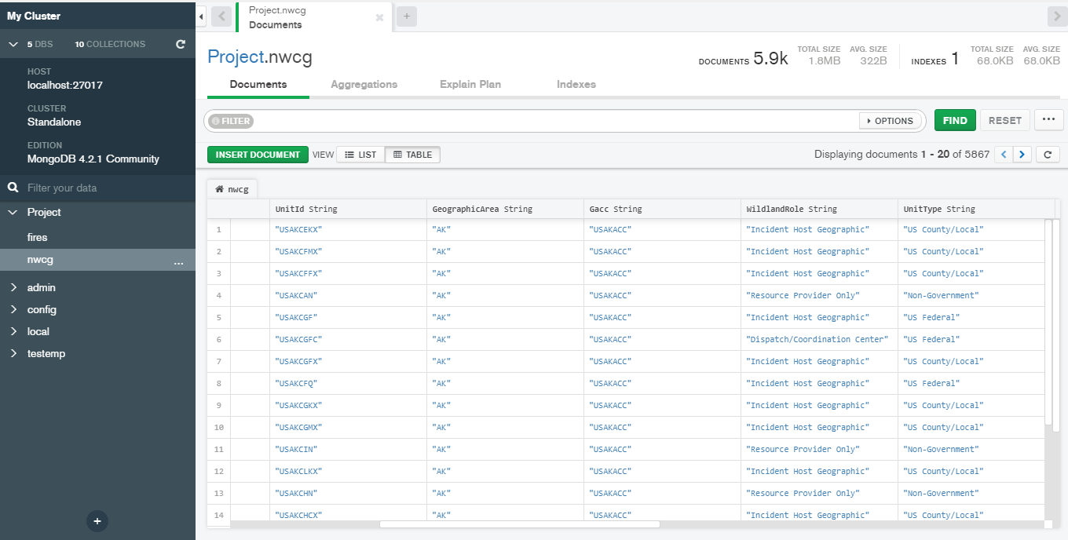

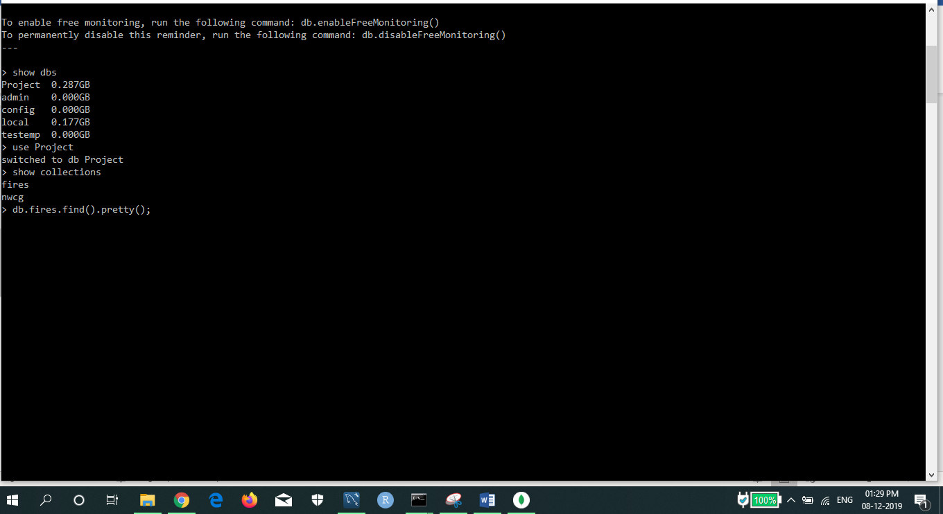

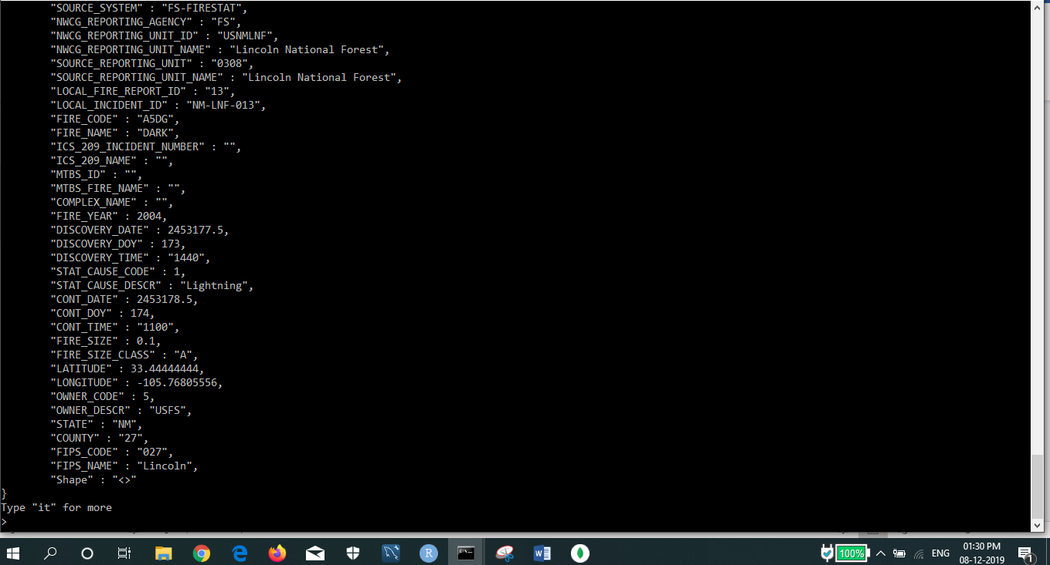

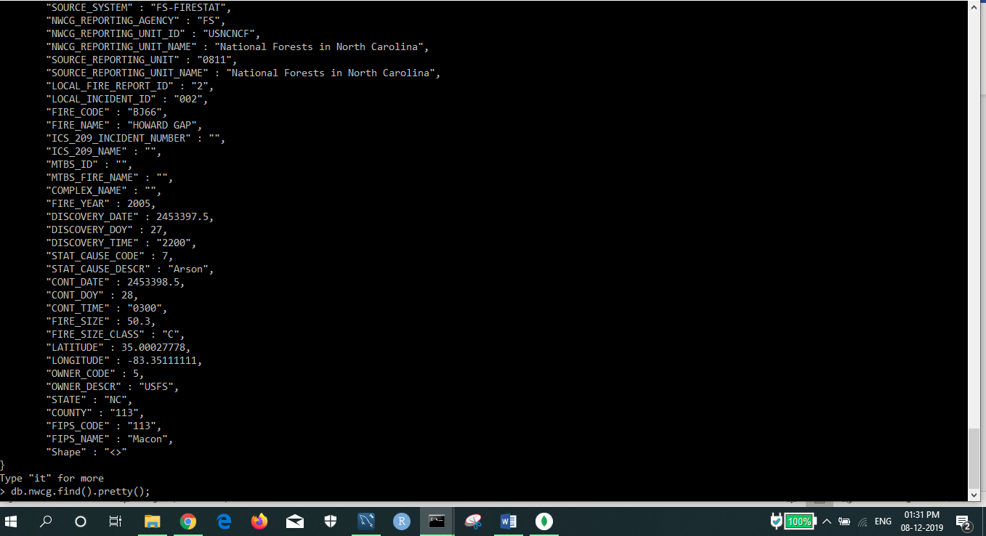

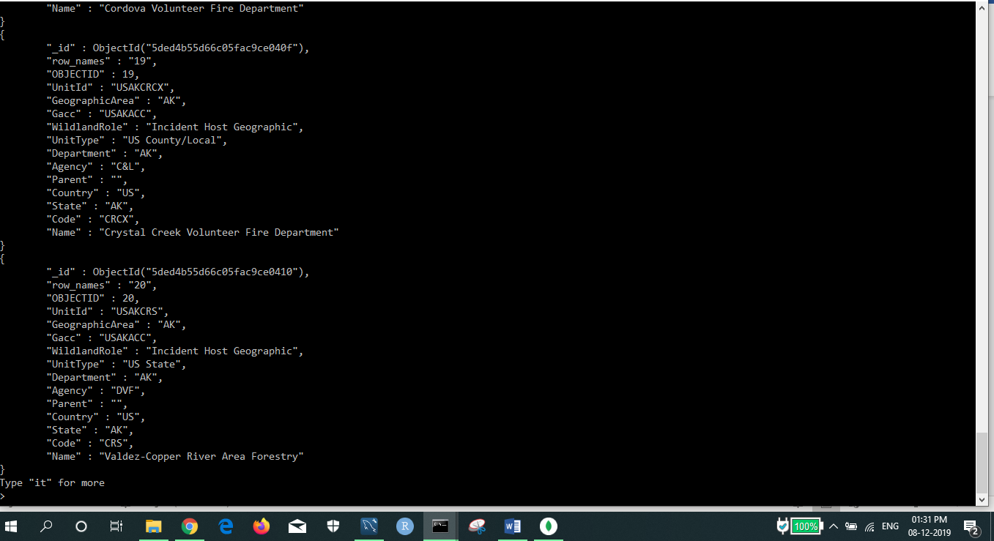

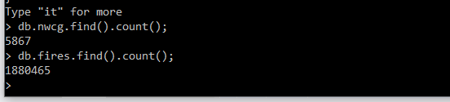

## Data in the Database

|  |  |  |
| --- | --- | --- |
| **Collection Name** | **Relationships with Other Collections (if any)** | **# of Documents in Collection** |
| Fires | - | 1880465 |
| NWCG | - | 5867 |

# MongoDB Queries/Code

## Query 1

### Question

**Q 1) A leading beverage company has announced a billion-dollar fund for removing debris from forests, rivers and mountains in the US. All states are interested. Which state has the best chance to win a share of the fund?**

### Notes/Comments About MongoDB Query/Code and Results (Include # of Documents in Result)

**Here the beverage company would most likely give a share of the fund to the state which has highest count of fires caused due to debris burning – so that the state can use the fund to clean its debris and reduce the number of fires caused due to it in future.**

### Translation

**Find STAT_CAUSE_DESCR matching to ‘Debris Burning’ from Fires Collection where**

**Grouped by State field**

**Sorted in descending order of fire count**

**Limiting the number of documents to 1**

### Screen Shot of MongoDB Query/Code and Results

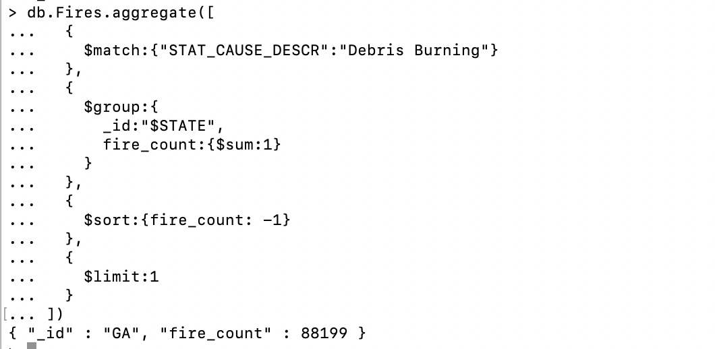

**The state of Georgia (GA) had the most no. of fires (88199) caused due to Debris Burning. Hence, Georgia has the best chance to win.**

## Query 2

### Question

**Q 2) One of the reporting agencies has suggested that children be banned from its forests unless there is one adult for every 3 children in a group visiting a forest. Name 3 forests where this would be the most appropriate.**

### Notes/Comments About MongoDB Query/Code and Results (Include # of Documents in Result)

**Here we need to find top 3 forests where most fires are caused by children. That is, children are the cause of Fires. Such forests would need a rule of children being accompanied by an adult to prevent fires caused by them in future.**

**Assumption: We have considered NWCG_Reporting_Unit field for our results.**

### Translation

**Find STAT_CAUSE_DESCR matching to ‘Children’ from Fires Collection where**

**Grouped by NWCG_Reporting_Unit_Name field**

**Sorted in descending order of fire count**

**Limiting the number of documents to 3**

### 

### Screen Shot of MongoDB Query/Code and Results

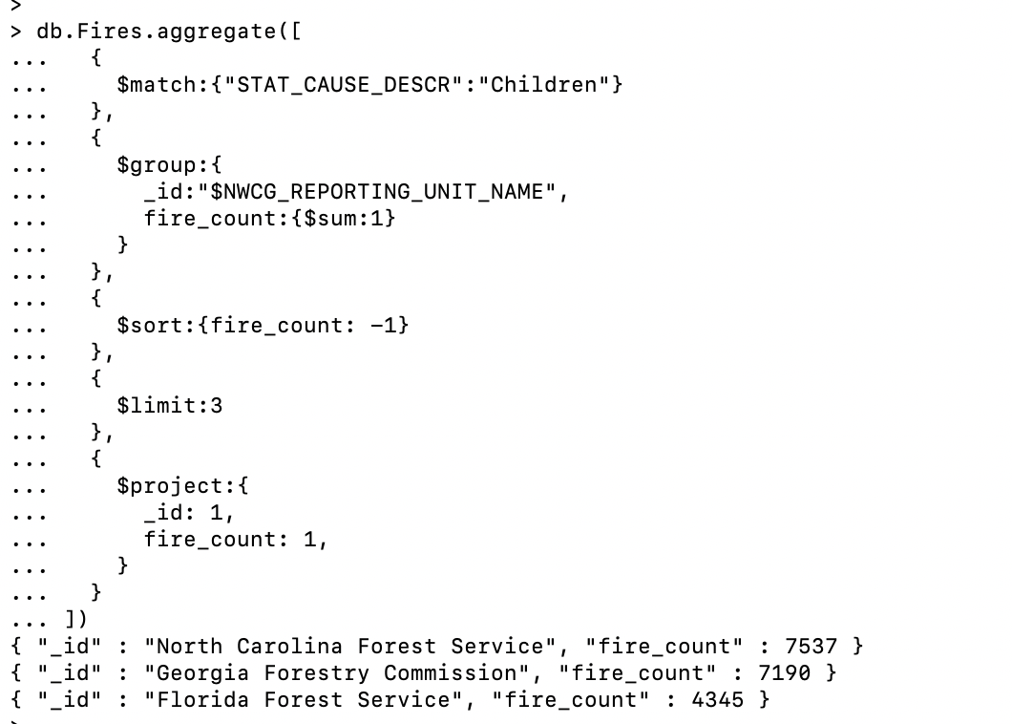

**The 3 forests: North Carolina Forest, Georgia Forest, Florida Forest had the most fires caused due to Children. Hence, these are the 3 forests where the ban would be the most appropriate.**

## Query 3

### Question

**Q 8) Which forest had the most number of fires?**

### Notes/Comments About MongoDB Query/Code and Results (Include # of Documents in Result)

**We have considered NWCG_Reporting_Unit_Name for our results.**

### Translation

**Project NWCG_Reporting_Unit_Name from Fires Collection where**

**Fire count is maximum**

**Sorted in descending order of fire count field**

**Limiting the number of documents to 1**

### Screen Shot of MongoDB Query/Code and Results

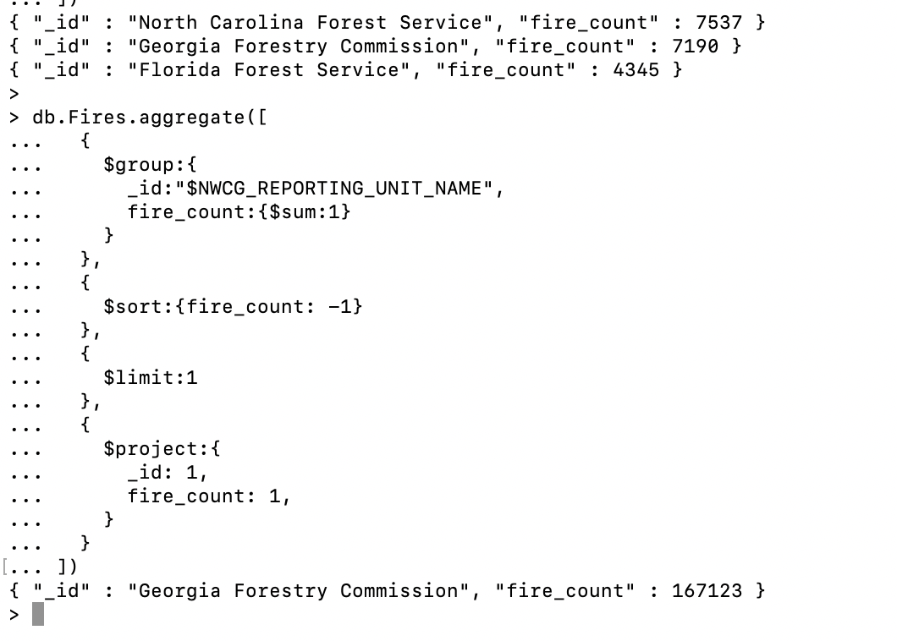

**The Georgia Forest had the most number of fires (167123).**

## Query 4

### Question

**Q 3) One advocacy group says Nature and not human actions is to blame for most wildfires. Write a query that supports this statement.**

### Notes/Comments About MongoDB Query/Code and Results (Include # of Documents in Result)

### **As per the NWCG Report, Debris burn escapes are one of the leading specific causes of wildland fires. Windblown embers or fire creeping from the controlled burn area into un-cleared vegetation are the primary ignition mechanisms of the wildfire. Hence, we make 2 assumptions about wildfires when cause is debris.**

### Translation

**Find Stat_Cause_Descr = `Lightning’ AND Stat_Cause_Descr = `Debris Burning’, then increment count of Natural Causes by 1**

**Else**

**Stat_Cause_Descr = `Miscellaneous’ AND Stat_Cause_Descr = `Missing/Unidentified’ then increment count of Man-Made by 1**

### Screen Shot of MongoDB Query/Code and Results

Assumption 1) **We consider debris burning as Natural cause. Now we can support the claim of advocacy group that nature and not human actions is to blame for most wildfires.**

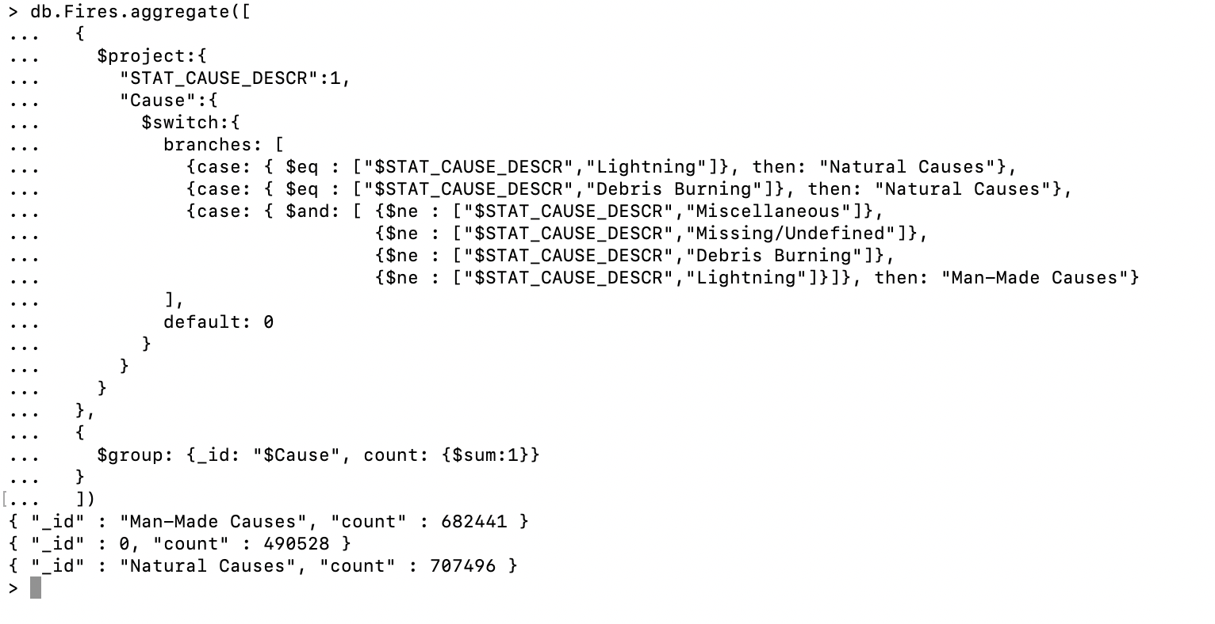

### Translation

**Find Stat_Cause_Descr = `Lightning’ , then increment count of Natural Causes by 1**

**Else**

**Stat_Cause_Descr = `Miscellaneous’ AND Stat_Cause_Descr = `Missing/Unidentified’ then increment count of Man-Made by 1**

Assumption 2) **If we consider debris burning as both man-made and natural cause of fires and hence not include in any group. Hence, here we cannot support the claim of advocacy group.**

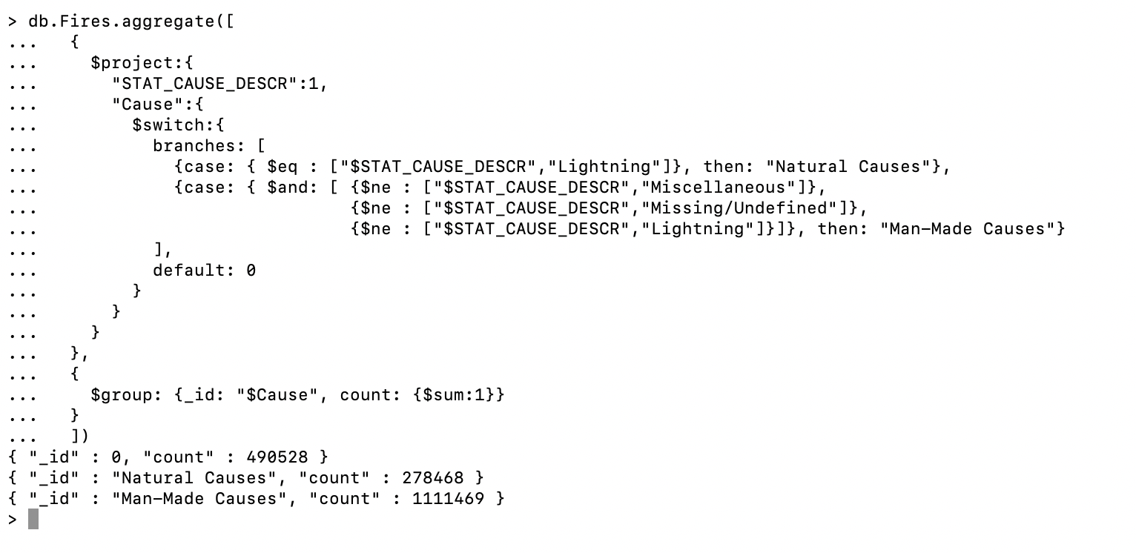

## Query 5

### Question

**Q 6) What were the forests that had more than one fire that lasted more than two days?**

### Notes/Comments About MongoDB Query/Code and Results (Include # of Documents in Result)

**We have considered NWCG_Unit table which contains a list of Forest names.**

### Translation

**Find difference of dates between Controlled Date and Discovery Date and check whether it is greater than 2. Group by NWCG_Reporting_Unit_Name.**

### Screen Shot of MongoDB Query/Code and Results

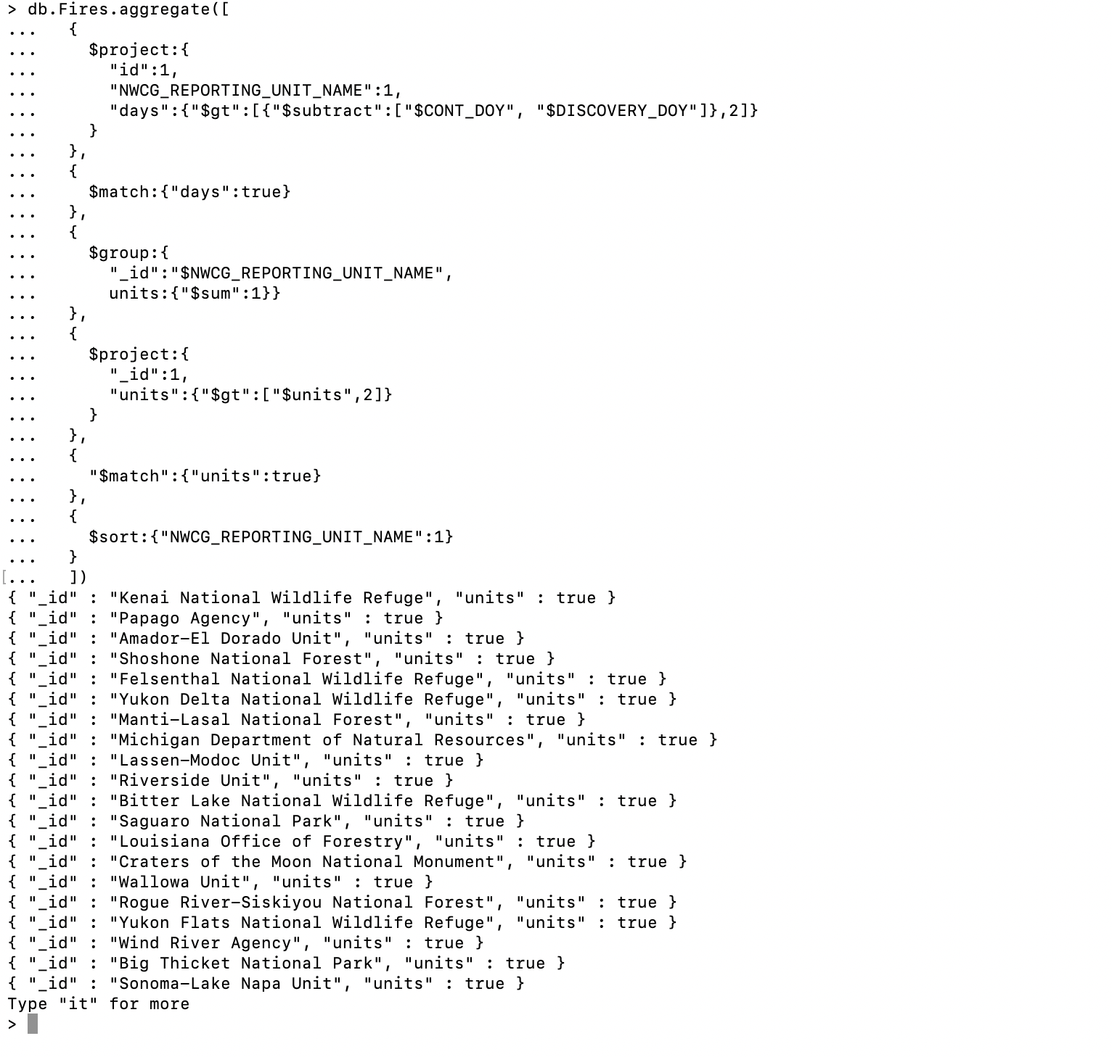

## Query 6

### Question

**Q 5) How many wildfires were reported by more than one unit/agency?**

### Notes/Comments About MongoDB Query/Code and Results (Include # of Documents in Result)

**We consider NWCG_Reporting_Unit_Name**

### Translation

**Count NWCG_Reporting_Unit_Name by Fire_Name**

### Screen Shot of MongoDB Query/Code and Results

